**Alex Hyman**

**9 September 2018**

**Final Project Report**

Table of Contents

Introduction 2

Data Sources and Data 2

Federal Elections Commission (fec.gov) 3

Structured Data 3

Semi-Structured Data 4

U.S Census Bureau 4

United States Department of Labor Website 5

Methods of Analysis 5

Description of Program 6

Cleaning 6

Transforming 7

Getting the Candidates 7

Separating by Chambers of Congress 7

Scraping the Web 8

Grouping the Races 8

Analyzing 8

Statewide Spending 8

Districtwide Spending 9

Formatting 10

Statewide Spending TopoJSON 10

Districtwide Spending TopoJSON 10

All Spending on Donations 11

Project Roles 12

Conclusions 13

Appendix A: Data Dictionaries 14

Candidate.txt Data Dictionary 14

cand2.txt Data Dictionary 15

committee.txt Data Dictionary 17

candidate_committee.txt Data Dictionary 18

Individuals Folder Data Dictionary 19

Appendix B: FEC Website Screenshot Example 23

Appendix C: Visualization Screenshots 24

# Introduction

While most people are aware that there is a lot of money in politics, fewer people are aware of who is donating the money and where the money is going. The primary sources of money to candidates are U.S Citizens (individuals) and Political Action Committees (PACs)[1]. Individuals are limited to donating $2,700 per candidate while traditional PACs are limited to donating $5,000 per candidate. Federal political candidates are able to accept unlimited amounts of money for their elections, but must itemize all donations greater than $200. While the donations that the individuals and PACs make are intended for the candidates, the money actually goes to a committee that is associated with a candidate.

All money raised by a candidate’s committee during an election cycle is reported to the Federal Election Committee (FEC) quarterly, and line items include total individual contributions (itemized and unitemized), party committees contributions, and other committee contributions (PACs). All itemized donations are also reported quarterly, and include the amount, and information about the donor (including name, address, state, occupation).

The purpose of this project is to analyze how Republicans and Democrats are donating their money for the 2018 midterm elections, and where the money is being prioritized. The midterm elections to each of the house and senate races will be analyzed. A statewide analysis of spending on the midterm elections will also be conducted. The categories of campaign money that will be analyzed will include: total money donated, total money donated by all individuals, total itemized donations from individuals within the state, total itemized donations from individuals outside of the state, and total donations from Political Action Committees. Questions that we would like this analysis to answer include:

* Which states are receiving the most donations for political purposes?
* Which congressional race is receiving the most amount of campaign donations?
* Which congressional races are receiving the most money from both parties?
* How do the sources of funds differ between Republicans and democrats?
* Which Senate race is receiving the most campaign money?

# Data Sources and Data

Data for this analysis is from multiple sources and includes both structured and semi-structured file types. Because there were a lot of different analysis conducted, some of which could take hours to complete, some of the data used in parts of the program were constructed and saved as a .csv or .tsv file, and had analysis conducted on the earlier constructed data. The data described in this section is the raw data collected directly from the source, without any cleaning or transforming conducted. Descriptions for the cleaned and transformed data used later in the program will be provided in the program description.

## Federal Elections Commission (fec.gov)

The Federal Elections Commission (FEC) website maintains all campaign finance data for all federal offices. The data maintained on this website tracks candidates running for office, as well as registered PACs and itemized donations to candidates. The FEC website maintains a bulk data section, that provides a convenient way to download some of the data provided on the website. The website also has candidate specific pages, where the finance data has already been aggregated for this election cycle (2017 – 2018). Because this project was conducted before the 15 October 2018 deadline for Q3 reporting, all of the data is from instances between 1/1/2017 – 6/30/2018. Below will describe both the structured and semi-structured data used for analysis.[2]

### Structured Data

The structured data for this analysis was collected in a direct download from the bulk data section on the FEC website. All files described in this section are text files that separated the data items with a vertical bar (“|”) and had a separate comma separated values file for the header of the data.

#### candidate.txt

The candidate.txt file is a text file that has a record of every candidate that has registered with the FEC or appeared on a ballot prepared by a state election’s office. A data dictionary is provided by the FEC website, and has been supplied in Appendix A. The main use of this file in the analysis will be to supply the state and office district, if applicable, for each of the candidates. Note, this file contains candidates that have run for office in the past, and have upcoming elections no in 2018.

#### cand2.txt

The cand2.txt file is a text file that has a record of every candidate that has raised or spent money during the 2017-2018 election cycle, even if they are not running for election in during the 2018 midterms. The main purpose of the cand2.txt file is to find out which candidates are running for election in the 2018, and filter out the candidates on the ballot in 2018. A data dictionary is provided by the FEC website, and has been supplied in Appendix A.

#### committee.txt

The committee.txt file contains all instances of committees that have registered with the FEC. This includes Political Action Committees, Party Committees, and campaign committees. Party committees are not included in the scope of this analysis, but it is necessary to have the committee that is associated with the candidate and the political action committees. A data dictionary is provided by the FEC website, and has been supplied in Appendix A.

#### candidate_committee.txt

The candidate_committee.txt file provides all instances of candidates their corresponding campaign committees. Because a candidate can have more than one committee (candidate was congressman, now running for senate), the file acts as a table of foreign keys mapping candidates to their campaign committee. A data dictionary is provided by the FEC website, and has been supplied in Appendix A.

#### Individuals Folder (7 individuals.txt files)

The individuals folder provides a transaction level itemization of donations by individuals to committees. Because the file is so large, the FEC provides all the itemized transactions reported by committees into seven different files in a folder called individuals. While this is not a full accounting of all donations to individuals (only donations greater than $200 need to be itemized), this is the only method available to evaluate the origin of state for any donations. This will be the primary purpose these files. A data dictionary is provided by the FEC website, and has been supplied in Appendix A.

### Semi-Structured Data

In addition to the data provided in the bulk data section of the FEC website (described earlier), each campaign committee also has their own web page[3] with a summary of money raised for the candidate during the current election cycle. It is also important to note that candidates running for the senate are could be collecting money for this election since 2012; however, the time period of analysis is money donated since the 2016 election, therefore an adjustment must be made to URL to not include the full election cycle, but only since the 2016 election. This has the effect of keeping the length in time raising money between the incumbent and challenger the same, and to evaluate donations since the contentious presidential election.

This web page of the candidate’s campaign committee provides the aggregated amount of total money raised by the campaign as well as the sum of donations by individuals and sum of donations by PACs to the campaign committee. A sample screenshot of the campaign committee web page is provided in Appendix B.

## U.S Census Bureau

Because I would like to add a spatial aspect to the analysis, a GeoJSON of the congressional districts of the United States was required. The U.S census bureau provides the updated congressional shapes in geography section of their website. The GeoJSON file with the geographic data of the congressional districts will later be used with the processed campaign data for a geographical analysis. The raw congressional GeoJSON file provided is called us-113-congress.json. [4]

In addition to a congressional level analysis, analysis on a statewide scale will be conducted. A similar analysis for all races within the state will be conducted and mapped to another GeoJSON file called us.json.

## United States Department of Labor Website

The unique ID’s of the states and districts are based upon the Federal Information Processing Standard (FIPS) Code of the state. This was obtained by reading a table provided on the Bureau of Labor Statistics web page.[5] The purpose of this table is simply to merge the state abbreviation with their corresponding FIPS code.

# Methods of Analysis

The python library Pandas was used as the primary manipulator of data, and the units of analysis are campaign money donated by all individuals, campaign money donated individuals residing in the state of the campaign donation, campaign money donated individuals residing in a state outside of the campaign donation, and campaign money donated by registered Political Action Committees on a statewide basis (campaign money donated to any race in the state), on a congressional district basis, and on a statewide basis for only senate elections. Only monies donated to the Democratic party and the Republican party were evaluated. The money was also evaluated on a geographical level as opposed to a candidate level, primarily due to primary elections had not been completed until September 12, 2018, and because this analysis is measuring all Political Party money, not just general election money.

The candidates used for this evaluation were limited to any Republican or Democratic candidate running for the House of Representatives or the Senate at any point from January 1, 2017 to the present. After filtering the candidates for analysis, the itemized donations by individuals files were looped through find the total amount of money donated to a candidate from within the state the candidate’s election is occurring, and the total amount of money donated to a candidate from outside the state the candidate’s election is occurring.

After the origin of individual donations were totaled, web scraping of the FEC website using each of the candidate’s unique ID was conducted to find out the total amount of money raised by the candidate, the total amount of donations by individuals, the total amount of donations by PACs, and the amount of donations by Political Party Committees.

To evaluate the statewide trends in donations to political candidates, all the candidates were grouped by state and party, and had their donation categories summed. This typically resulted in two rows for each state, one representing money donated to candidates of the Democratic Party within the state, and one row representing all money donated to candidates of the Republican Party within the state. Each of the categories within the state were summed together, and a percentage of money that went to Democrats in each of the donation categories was calculated. The percentage scale of each category will compare the money coming into the state for elections by the two main parties.

In addition to a statewide analysis, each race in the house and senate were evaluated independently. Using the candidate list with donation summaries, candidates were separated by chamber of congress they were running for, and then grouped by election and party. Candidates for the Senate were grouped by state and party and had their donation categories summed. Candidates for the House of Representatives were grouped by state, district, and party, and had their donations summed. The percentage of money that was going to the Democrat in each race was calculated.

One final metric that I used to act as an index for competition was called the Intensity index. The theory behind this index variable is to determine the amount of money being donated to the party with less cash, and find the z-score for the minority party’s money raised. I believe, that by using the cash raised as an indicator, the statistic will provide an idea of where the midterm elections could be competitive on a district scale.

Because the number of races are large, and would make for a less intuitive table, the calculated values were entered as properties in the geographic JSON file for a spatial/visual analysis. The JSON file is then used by a d3-powered web page to provide interactive visualizations for the analysis. The visualizations created using this program will be the basis of all analysis. The analysis would not be possible without the scripting and calculations conducted by python.

# Description of Program

The program developed for this analysis was initially developed as a few separate scripts to separate out the different steps in analysis. The program’s analysis pipeline follows the process of cleaning, transforming, analyzing, and formatting. Some intermediate files were utilized as placeholders for the program because some steps required significant amounts of time to complete. The process in each of the steps is sections below.

**NOTE:** Because this program deals with a large amount of data, the program takes approximately 2.5 hours to run all the way through. The large amount of time is primarily due to web scraping.

## Cleaning

First, the program must convert the data gathered from the bulk download section of the FEC website from .txt files to .csv files. These files will act as the base data of our analysis. The files that will be converted include:

* Candidate information
* Committee information
* Candidate to Committee linkage
* Political Action Committee (PAC) information
* PAC donations to candidates
* Itemized donations from Individuals to candidates

The cleaned data files are saved in a separate “cleaned” folder as a .csv file to ease the burden of converting the files into a structured format every time.

## Transforming

While the initial data is now in a structured format that can be read easily, the data is still not formatted exactly as it should be. Several data files are manipulated and created to ensure that the data is accurate. The steps are as follows:

### Getting the Candidates

After the data has been cleaned into a structured format, the corresponding campaign committee for the candidates must be merged together, and a new structure must be created associating all candidates with at least one campaign committee. If the candidate does not have a campaign committee, then they will not be include in this analysis as the candidate will be unable to raise money.

In addition to the candidate to committee linkage, a list of all unique candidate IDs will be created so there will only be one instance per candidate in the analysis. A dictionary will also be created using the candidate ID as the key, and a dictionary of the name, party, and state as the initial keys in the candidate dictionary.

Via a for loop through the folder of itemized individual donations to candidates and committees, and a for through the candidate IDs, we will determine the total amount of donations to the campaign from within the state, and the total amount of donations to the campaign from outside the state. This will be accomplished by indexing the pandas data frame for all itemized donations where the candidate state is the same as the donor state and taking the sum, and index all the itemized donations where the candidate state is not the same as the donor state and take the sum. These will be saved in the candidate dictionary as *localDonations* and *oosDonations* (out-of-state). If there were any candidates that did not appear in the individual donations list, a zero was manually entered by the program. Candidates were also removed from the dictionary if they did not have a state listed (Presidential candidates) or if they had not received and donations from any individuals or PACs. This dictionary of candidate information was then saves as candidateSummary.tsv file as an intermediary step in a long process.

### Separating by Chambers of Congress

Next, the program needs to separate the candidates running for the House of Representative from the candidates running for the Senate. To do this, the program will open back up the candidateSummary.tsv file and open a cleaned candidates.csv file to match the candidates with their election year, and find all candidates with that have an election in 2018.

Then the program looks at the first letter of the candidate’s ID, and if it begins with an “S”, it saves these candidates as senate candidates, and if it begins with an “H” it saves these candidates as House of Representative candidates. The program also makes sure that the senate candidates ate within the 33 states that have an election this year. The list of candidates for the house and senate are then saved to separate .csv files to simplify the analysis for future steps.

### Scraping the Web

After getting the list of candidates for the house and the senate, the program will collect subtotals as summarized by the FEC’s candidate summary page. Looping through the candidate ID’s for both the house and the senate, the program accesses the candidate summary page and extracts the total amount raised, total amount donated by individuals, the total amount donated by the party, and the total amount donated by PACS. These amounts are saved as a list and added to an empty list to later save as a .csv file. The strings extracted from the web page are also converted into float type numbers and the scraped vales are saved in the HouseSummary.csv and SenateSummary.csv files.

### Grouping the Races

While having summarized information on the candidate is beneficial, the most important aspect of this analysis is which part is receiving the donations. This is important because at the time of the data extraction, not all of the races had been decided (still had primaries).

To have a better understanding of how the parties are raising money for the 2018 midterm elections, the program read the HouseSummary.csv and the SenateSummary.csv into a separate pandas data frame. The House of Representatives data frame was then grouped by state, district, and party, and had their donation amounts summed. The senate candidates data frame was grouped by state and party and had their donation totals summed. This resulted in two different data frames, one had rows with instances for each party’s candidate for an election in the state’s district and the grouped totals, the other had instances for each party’s candidate for the senate and the grouped totals. These data frames were saved in separate .csv files: HouseGrouped.csv and SenateGrouped.csv.

## Analyzing

Now that the data has been transformed into useful, structured files, the program needs to gather meaning from the data. The program will accomplish this on a couple of different levels, and for a few different metrics. The process behind this analysis is described below.

### Statewide Spending

One level of analysis the program will explore is how the spending is directed on a statewide level. To do this, the program will first read a States table so the states that are raising money can be associated with their FIPS code for geographic analysis. The HouseGrouped.csv and the SenateGrouped.csv files are then opened, and a new data frame is created to index only Democratic and Republican candidates for congress. The house and senate data frames are then stacked to have a data frame of all the instances of raising money for Democrats and Republicans in the house and the senate

The combined data frames is then indexed for only the categories of interest: total amount of money raised, total amount of money donated by individuals, total of itemized money donated by individuals in the candidate’s state, the total amount of itemized donations from individuals outside of the candidate’s state, the total amount of money donated by PACs; and then, grouped by party and state. The program then indexes all of the Democrat’s state totals and renames the columns with a “Dem” prefix, and then it indexes the Republican’s state totals and renames the columns with a “Rep” prefix. The original combined House and Senate Data frame is then grouped by state, so totals for both parties can be calculated.

The state totals data frame is then combined with the Democrat’s data frame, and then the percentage of state money being donated to Democrats is then calculated for each of the categories of interest. Finally, the republican money is merged with the data frame, so the data frame has the totals of money going to Democrats, the totals of money going to Republicans, and the percentage of money going to Democrats for each of the categories, and each of the states. This is then saves as a AllStateMoney.csv for future formatting.

### Districtwide Spending

As was the case for statewide spending, the program also needs to analyze spending on a district level. This was done by reading the HouseGrouped.csv file and first creating a unique district ID for each district. The district ID was created combining the state FIPS code as a string with the two digit district number as a string (single digit numbers had a 0 in front) and the IDs were then converted back to integers.

The data frame was then indexed into separate data frames for Republicans and Democrats and another data frame was the summed amount for each category in the district. This total amount was then merged with the Democrats data frame as an outer merge, so there were no missing districts if only Republicans donated, and the percentage of district wide money donated to Democrats in each category was also calculated.

In addition to percentage of money donated to democrats in each category, the intensity index was also calculated. This was determined by looking at the percentage of all money raised by Democrats, and if a row was greater than 50%, the Republican percentage was calculated by subtracting the Democrat percentage from 100%. This resulted in knowing the percentage of districtwide money donated to the party that raised the least amount of money. This value was then multiplied by the total of money raised by both parties to determine the amount of money raised by the party with less money raised. Using this column, the z-score of the money raised by the minority party was calculated. This value will now be the intensity index.

## Formatting

Because the primary purpose of this analysis is to provide a spatial and relational visualization to the spending on political campaigns by democrats and republicans, the final step in this program is putting these calculated and summarized values into usable file formats. Because the primary vehicle for visualization (d3.js) is a JavaScript based library, the data we want to visualize needs to be in a JSON format. Two of the output files will be TopoJSON, meaning they will represent topographical data, and one output file will be strictly a JSON format. The formatting of the data is as discussed below.

### Statewide Spending TopoJSON

To represent the statewide spending, the program reads the us.json input file. This file contains county, land, and state geometries. First, the program indexes the state geometries, to make a variable that is a list of dictionaries that contain an ID, and the geometries for the states. The keys for these state geometries are the same FIPS codes that were merged into the candidates data frame.

After the state dictionaries have been saved in a variable, the program opens the AllStateMoney.csv and retrieves all of the column names. The program then loops through each of the states in the list of dictionaries and creates a key in the in the state called properties that is set equal to a dictionary. After retrieving the ID from the state geometries list, the corresponding row in the state spending data frame is then indexed. Using the indexed row, each column name of the state spending data frame is entered as a key saved in the properties dictionary, and the corresponding value is entered as the value. After finishing the looping through the states, then indexes the row of the pandas data frame and add the states list is inserted back into the us.json, and a new file is created called stateData.json. This JSON file will be used in the visualization of the categorical donations on a statewide level.

### Districtwide Spending TopoJSON

Tor represent districtwide spending, the program reads the us-113-congress.json file, and converts it into a list of dictionaries that contains the 435 congressional districts with an ID that is identical to the district ID created earlier (concatenation of FIPS Number and 2-digit district number).

After the districts have been saved in a variable, the program loops through each of the districts in the list of district dictionaries, and finds the ID if the district. The program also inserts a key called “properties” into the district, that has a value of an empty dictionary. The program then indexes the row of the district spending data frame created earlier using the ID of the district in the dictionary. There should only be one row indexed, and it will contain the percentage of money going towards democrats, as well as the intensity index. With this row, the program loops through all of the column names, and inserts them as a key in the properties dictionary with the value being the corresponding value in the row’s column. After looping through all of the districts, the program re inserts the list of dictionaries into the JSON opened earlier, and saves the newly edited dictionary as districtData.json. This JSON file will be used in the visualization of categorical donations on a district level, and a visualization of intensity of the election in the district.

### All Spending on Donations

The final output that the program wants to save is a dictionary that itemizes total spending on elections within the state by election and party. This is accomplished by the program by first reading in the HouseGrouped.csv and the SenateGrouped.csv files into separate data frames. The program then creates a unique list of states by using a set on the states in the house of representatives and it concatenates the state abbreviation with the district number to create a more aesthetically pleasing way to distinguish the different house races.

Before the loop through the states begins, a dictionary is initiated that contains the keys of “name” and an empty list is initialized where the “children” will be held. This structure is repeated multiple times as is shown in the figure below representing the structure of the dictionary and the final output JSON file.



Figure 1 JSON Structure for All Money Raised

After the “children” list has been initialized, the program begins to loop through the list of unique states. For each state, a dictionary specific to that state is created with a key “name being the state name, and an empty list is created. The program then indexes all of the rows in the HouseGrouped.csv data frame that are in the same state. A new list of unique house districts within the state is then created along with new dictionary for the house with key “name” being “House of Representatives”, and an empty list is created for each of the house districts.

The program then loops through each of the house districts, and creates a new empty dictionary with the name being the aesthetically pleasing district name, and a unique list of parties is creates, as is an empty list for the specific party statistics. The program finally loops through the parties and indexes the columns for total raised and party name for the corresponding party. A new dictionary is then created that stores the name of the party and the amount raised by the party in the district. This dictionary is then appended to the empty list for the district.

After the program is done looping though the parties in the district, a key, “children”, is entered into the district dictionary with the value of the list of candidate dictionaries and the district dictionary is appended to the list of districts. Once all of the districts have been looped through, a key “children” is entered in the house dictionary with the value being the list of all the district dictionaries, and the house dictionary is added to the dictionary for the state.

If the program finds any senate candidates senate data frame the program is looping through, the program creates a dictionary to hold the senate candidates and an empty list is created. The rows in the senate data frame is then indexed for the candidates in the state, and a dictionary is created for each candidate with their party and amount raised. This dictionary is appended to the empty list. When the candidates have all been looped through, a key “children” is entered into the senate dictionary, and the value is the list of senate candidate party’s dictionaries. The senate dictionary is then appended to the state list that already contains the house dictionary. If the program did not find any senate candidates, the program skips this step altogether.

Once the state has been completely looped through, the state dictionary has a key “children” added to it that contains the list with the house dictionary and potentially the senate dictionary (if there were candidates). The state dictionary is then appended to the empty list that will contain each dictionary for each of the states.

Once all of the states have been looped through, a key “children” is added to the dictionary of AllElections, and the value will be the list of all state dictionaries. The dictionary is finally saved as AllElections.json and will be used in the visualization of all money raised for campaigns within all the states.

# Project Roles

This was an individual project by Alex Hyman. All scripting was completed by myself as were all visualizations. The visualizations created were inspired by the tutorials provided by the creator of d3, Mike Bostock[6].

# Conclusions

The output files were then used to create visualizations representing the various categories measured and calculated[7]. The first conclusion was that California is raising more campaign money for their elections than any other state. While this may be obvious because there are more congressional races in the state than any other states and there is currently a senate campaign, it is astounding that more than $180,000,000 has been raised by all candidates.

California is then followed by Texas, Florida, New York, and Pennsylvania as the top 5. All of which have many congressional races and a senate election.

The second conclusion is that the congressional races that have received the most money are CA-49 and CA-39. Both congressional districts are located in wealthy areas in southern California, and are currently represented by Republicans who are not seeking re-election. In both districts, the democrats in the district have outraised the republicans by more than $5,000,000.

The analysis of competition in the different election campaigns was measured by the created intensity index value. This in effect measured how much money the party that had raised the lesser amount of money in the district compared the amount of money in other districts the party raising less money had raised. The most competitive race, in terms of minority party raised, happened to be WI-01, is a district currently represented by the current Speaker of the House, Paul Ryan, who is no longer seeking election. Other districts that scored high on the intensity index included CA-39 and CA-49 as previously mentioned. Other districts that appear competitive via the intensity index are either districts that had a special election earlier this year (OH-12), districts that are in the suburbs (TX-32 Dallas, VA-10 Washington DC), or districts that are represented by candidates no longer seeking election (NJ-11 R-Frelinghuysen, WI-01 R-Ryan, CA-59 R-Issa).

When looking at the percentage of all money being raised by the parties on a statewide basis, the map tends to be pretty purple (~50%). However, looking at all of the itemized donations by individuals, the map tends to get a bit darker/blue. This would mean that compared to the baseline of all money raised, a higher proportion of Democrat’s money has been donated by people than other sources. However, when looking at money donated to the states by PACs, a greater proportion is donated to Republicans.

When analyzing the itemized donations by individual (typically > $200) to the states, one of the more interesting trends is there is a lot more money being donated to Democratic candidates by individuals outside of the state, than from individuals inside the state; this is especially the case in states that currently have a Democratic Senator up for re-election in states that were won by Donald Trump in 2016 (MT D-Tester, FL D-Nelson, ND D-Heitkamp, WV D-Manchin).

When analyzing on the district level, it is first apparent how red the map is in terms of area. But when looking closely, it becomes apparent that some of the small splotches of blue are in fact many districts. This is most apparent in Illinois, where nearly 70% of the state is red by area, but the small bit of blue by Chicago is more than ten different districts. The trend in PAC donations to districts becomes even more apparent in the visualization; however, When comparing out-of-state donations to the districts compared to in-state donations, more money appears to be coming from outside of the state for Republican candidates.

Visualizations can be viewed at: <https://politicaldonations.000webhostapp.com/>. Screenshots are provided in Appendix C.

# Appendix A: Data Dictionaries

## Candidate.txt Data Dictionary[8]

|  |  |  |  |  |
| --- | --- | --- | --- | --- |
| **Column name** | **Field name** | **Data type** | **Description** | **Example data** |
| CAND_ID | Candidate identification | VARCHAR2(9) | A 9-character alpha-numeric code assigned to a candidate by the Federal Election Commission. The candidate ID for a specific candidate remains the same across election cycles as long as the candidate is running for the same office. | H8VA01233 |
| CAND_NAME | Candidate name | VARCHAR2(200) |  | Martha Washington |
| CAND_PTY_AFFILIATION | Party affiliation | VARCHAR2(3) | The political party affiliation reported by the candidate | NON |
| CAND_ELECTION_YR | Year of election | Number(4) | Candidate's election year from a Statement of Candidacy or state ballot list | 2018 |
| CAND_OFFICE_ST | Candidate state | VARCHAR2(2) | House = state of race  President = US  Senate = state of race | VA |
| CAND_OFFICE | Candidate office | VARCHAR2(1) | H = House P = President S = Senate | H |
| CAND_OFFICE_DISTRICT | Candidate district | VARCHAR2(2) | Congressional district number Congressional at-large 00  Senate 00 Presidential 00 | 01 |
| CAND_ICI | Incumbent challenger status | VARCHAR2(1) | C = Challenger I = Incumbent O = Open Seat is used to indicate an open seat; Open seats are defined as seats where the incumbent never sought re-election. | I |
| CAND_STATUS | Candidate status | VARCHAR2(1) | C = Statutory candidate F = Statutory candidate for future election N = Not yet a statutory candidate P = Statutory candidate in prior cycle | C |
| CAND_PCC | Principal campaign committee | VARCHAR2(9) | The ID assigned by the Federal Election Commission to the candidate's principal campaign committee for a given election cycle. | C00100005 |
| CAND_ST1 | Mailing address - street | VARCHAR2(34) | Mailing address - street | 1001 George Washington Hwy |
| CAND_ST2 | Mailing address - street2 | VARCHAR2(34) | Mailing address - street2 | Suite 100 |
| CAND_CITY | Mailing address - city | VARCHAR2(30) | Mailing address - city | Alexandria |
| CAND_ST | Mailing address - state | VARCHAR2(2) | Mailing address - state | VA |
| CAND_ZIP | Mailing address - ZIP code | VARCHAR2(9) | Mailing address - ZIP code | 22201 |

## cand2.txt Data Dictionary[9]

|  |  |  |  |  |
| --- | --- | --- | --- | --- |
| **Column name** | **Field name** | **Data type** | **Description** | **Example data** |
| CAND_ID | Candidate identification | VARCHAR2 (9) |  | H8VA01233 |
| CAND_NAME | Candidate name | VARCHAR2(200) |  | Martha Washington |
| CAND_ICI | Incumbent challenger status | VARCHAR2(1) |  | I |
| PTY_CD | Party code | VARCHAR2(1) |  | NON |
| CAND_PTY_AFFILIATION | Party affiliation | VARCHAR2(3) |  | NON |
| TTL_RECEIPTS | Total receipts | Number(14,2) |  | 345,456.34 |
| TRANS_FROM_AUTH | Transfers from authorized committees | Number(14,2) |  | 4000.00 |
| TTL_DISB | Total disbursements | Number(14,2) |  | 175645.21 |
| TRANS_TO_AUTH | Transfers to authorized committees | Number(14,2) |  | 0.00 |
| COH_BOP | Beginning cash | Number(14,2) |  | 845901.23 |
| COH_COP | Ending cash | Number(14,2) |  | 915671.43 |
| CAND_CONTRIB | Contributions from candidate | Number(14,2) |  | 500.00 |
| CAND_LOANS | Loans from candidate | Number(14,2) |  | 250000.00 |
| OTHER_LOANS | Other loans | Number(14,2) |  | 0.00 |
| CAND_LOAN_REPAY | Candidate loan repayments | Number(14,2) |  | 100000.00 |
| OTHER_LOAN_REPAY | Other loan repayments | Number(14,2) |  | 0.00 |
| DEBTS_OWED_BY | Debts owed by | Number(14,2) |  | 250.00 |
| TTL_INDIV_CONTRIB | Total individual contributions | Number(14,2) |  | 450000.00 |
| CAND_OFFICE_ST | Candidate state | VARCHAR2(2 |  | VA |
| CAND_OFFICE_DISTRICT | Candidate district | VARCHAR2(2) |  | 01 |
| SPEC_ELECTION | Special election status | VARCHAR2(1) | Election result data included in 1996-2006 files only. | W |
| PRIM_ELECTION | Primary election status | VARCHAR2(1) | Election result data included in 1996-2006 files only. | L |
| RUN_ELECTION | Runoff election status | VARCHAR2(1) | Election result data included in 1996-2006 files only. | L |
| GEN_ELECTION | General election status | VARCHAR2(1) | Election result data included in 1996-2006 files only. | W |
| GEN_ELECTION_PRECENT | General election percentage | Number(7,4) | Election result data included in 1996-2006 files only. | 63.2 |
| OTHER_POL_CMTE_CONTRIB | Contributions from other political committees | Number(14,2) |  | 200000.00 |
| POL_PTY_CONTRIB | Contributions from party committees | Number(14,2) |  | 200000.00 |
| CVG_END_DT | Coverage end date | DATE(MM/DD/YYYY) | Through date | 10/19/2018 |
| INDIV_REFUNDS | Refunds to individuals | Number(14,2) |  | 4000.00 |
| CMTE_REFUNDS | Refunds to committees | Number(14,2) |  | 100.00 |

## committee.txt Data Dictionary[10]

|  |  |  |  |  |
| --- | --- | --- | --- | --- |
| **Column name** | **Field name** | **Data type** | **Description** | **Example data** |
| CMTE_ID | Committee identification | VARCHAR2(9) | A 9-character alpha-numeric code assigned to a committee by the Federal Election Commission. Committee IDs are unique and an ID for a specific committee always remains the same. | C00100005 |
| CMTE_NM | Committee name | VARCHAR2(200) |  | Martha Washington for Congress |
| TRES_NM | Treasurer's name | VARCHAR2(90) | The officially registered treasurer for the committee. | Alexander Hamilton |
| CMTE_ST1 | Street one | VARCHAR2(34) |  | 1001 George Washington Hwy |
| CMTE_ST2 | Street two | VARCHAR2(34) |  | Suite 203 |
| CMTE_CITY | City or town | VARCHAR2(30) |  | Alexandria |
| CMTE_ST | State | VARCHAR2(2) |  | VA |
| CMTE_ZIP | ZIP code | VARCHAR2(9) |  | 22201 |
| CMTE_DSGN | Committee designation | VARCHAR2(1) | A = Authorized by a candidate B = Lobbyist/Registrant PAC D = Leadership PAC J = Joint fundraiser P = Principal campaign committee of a candidate U = Unauthorized | A |
| CMTE_TP | Committee type | VARCHAR2(1) | [List of committee type codes](https://www.fec.gov/campaign-finance-data/committee-type-code-descriptions) | H |
| CMTE_PTY_AFFILIATION | Committee party | VARCHAR2(3) | [List of party codes](https://www.fec.gov/campaign-finance-data/part-code-descriptions) | NON |
| CMTE_FILING_FREQ | Filing frequency | VARCHAR2(1) | A = Administratively terminated D = Debt M = Monthly filer Q = Quarterly filer T = Terminated W = Waived | Q |
| ORG_TP | Interest group category | VARCHAR2(1) | C = Corporation L = Labor organization M = Membership organization T = Trade association V = Cooperative W = Corporation without capital stock | C |
| CONNECTED_ORG_NM | Connected organization's name | VARCHAR2(200) |  | Widgets, Incorporated |
| CAND_ID | Candidate identification | VARCHAR2(9) | When a committee has a committee type designation of H, S, or P, the candidate's identification number will be entered in this field. | H1VA01225 |

## candidate_committee.txt Data Dictionary[11]

|  |  |  |  |  |
| --- | --- | --- | --- | --- |
| **Column name** | **Field name** | **Data type** | **Description** | **Example data** |
| CAND_ID | Candidate identification | VARCHAR2 (9) | A 9-character alpha-numeric code assigned to a candidate by the Federal Election Commission. The candidate ID for a specific candidate remains the same across election cycles as long as the candidate is running for the same office. | H8VA01233 |
| CAND_ELECTION_YR | Candidate election year | NUMBER (4) | Candidate's election year | 2018 |
| FEC_ELECTION_YR | FEC election year | NUMBER (4) | Active 2-year period | 2018 |
| CMTE_ID | Committee identification | VARCHAR2 (9) | A 9-character alpha-numeric code assigned to a committee by the Federal Election Commission. The committee ID for a specific committee always remains the same. | C00100005 |
| CMTE_TP | Committee type | VARCHAR2 (1) | [List of committee type codes](https://www.fec.gov/campaign-finance-data/committee-type-code-descriptions) | H |
| CMTE_DSGN | Committee designation | VARCHAR2 (1) | A = Authorized by a candidate B = Lobbyist/Registrant PAC D = Leadership PAC J = Joint fundraiser P = Principal campaign committee of a candidate U = Unauthorized | A |
| LINKAGE_ID | Linkage ID | NUMBER (12) | Unique link ID | 123456789012 |

## Individuals Folder Data Dictionary[12]

|  |  |  |  |  |
| --- | --- | --- | --- | --- |
| **Column name** | **Field name** | **Data type** | **Description** | **Example data** |
| CMTE_ID | Filer identification number | VARCHAR2 (9) | A 9-character alpha-numeric code assigned to a committee by the Federal Election Commission | C00100005 |
| AMNDT_IND | Amendment indicator | VARCHAR2 (1) | Indicates if the report being filed is new (N), an amendment (A) to a previous report or a termination (T) report. | N |
| RPT_TP | Report type | VARCHAR2 (3) | Indicates the type of report filed [List of report type codes](https://www.fec.gov/campaign-finance-data/report-type-code-descriptions) | 12G |
| TRANSACTION_PGI | Primary-general indicator | VARCHAR2 (5) | This code indicates the election for which the contribution was made. EYYYY (election plus election year) P = Primary G = General O = Other C = Convention R = Runoff S = Special E = Recount | P2018 |
| IMAGE_NUM | Image number | VARCHAR2 (11) or VARCHAR2(18) | 11-digit Image Number Format YYOORRRFFFF YY - scanning year  OO - office (01 - House, 02 - Senate, 03 - FEC Paper, 90-99- FEC Electronic)  RRR - reel number  FFFF- frame number  18-digit Image Number Format (June 29, 2015) YYYYMMDDSSPPPPPPPP YYYY - scanning year  MM - scanning month  DD - scanning day  SS - source (02 - Senate, 03 - FEC Paper, 90-99 - FEC Electronic)  PPPPPPPP - page (reset to zero every year on January 1) | 201810170912345678 |
| TRANSACTION_TP | Transaction type | VARCHAR2 (3) | Transaction types 10, 11, 15, 15C, 15E, 15I, 15T, 19, 22Y, 24I, 24T, 20Y and 21Y are included in the INDIV file. Beginning with 2016 transaction types 30, 30T, 31, 31T, 32, 32T, 40T, 40Y, 41T, 41Y, 42T and 42Y are also included in the INDIV file. For more information about transaction type codes see this [list of transaction type codes](https://www.fec.gov/campaign-finance-data/transaction-type-code-descriptions) | 30T |
| ENTITY_TP | Entity type | VARCHAR2 (3) | ONLY VALID FOR ELECTRONIC FILINGS received after April 2002. CAN = Candidate CCM = Candidate Committee COM = Committee IND = Individual (a person) ORG = Organization (not a committee and not a person) PAC = Political Action Committee PTY = Party Organization | IND |
| NAME | Contributor/Lender/Transfer Name | VARCHAR2 (200) |  | Abigail Adams |
| CITY | City | VARCHAR2 (30) |  | Braintree |
| STATE | State | VARCHAR2 (2) |  | MA |
| ZIP_CODE | ZIP code | VARCHAR2 (9) |  | 02184 |
| EMPLOYER | Employer | VARCHAR2 (38) |  | Self employed |
| OCCUPATION | Occupation | VARCHAR2 (38) |  | Homemaker |
| TRANSACTION_DT | Transaction date (MMDDYYYY) | DATE |  | 10132018 |
| TRANSACTION_AMT | Transaction amount | NUMBER (14,2) |  | 1000.00 |
| OTHER_ID | Other identification number | VARCHAR2 (9) | For contributions from individuals this column is null. For contributions from candidates or other committees this column will contain that contributor's FEC ID. | C00100309 |
| TRAN_ID | Transaction ID | VARCHAR2 (32) | ONLY VALID FOR ELECTRONIC FILINGS. A unique identifier associated with each itemization or transaction appearing in an FEC electronic file. A transaction ID is unique for a specific committee for a specific report. In other words, if committee, C1, files a Q3 New with transaction SA123 and then files 3 amendments to the Q3 transaction SA123 will be identified by transaction ID SA123 in all 4 filings. | SA11A1A.8317 |
| FILE_NUM | File number / Report ID | NUMBER (22) | Unique report id | 1197695 |
| MEMO_CD | Memo code | VARCHAR2 (1) | 'X' indicates that the amount is NOT to be included in the itemization total. | X |
| MEMO_TEXT | Memo text | VARCHAR2 (100) | A description of the activity. Memo Text is available on itemized amounts on Schedules A and B. These transactions are included in the itemization total. | Reattributed from John Adams 10/5/18 |
| SUB_ID | FEC record number | NUMBER (19) | Unique row ID |  |

# Appendix B: FEC Website Screenshot Example



# Appendix C: Visualization Screenshots

**Percent of All Money Raised By All Candidates - States**

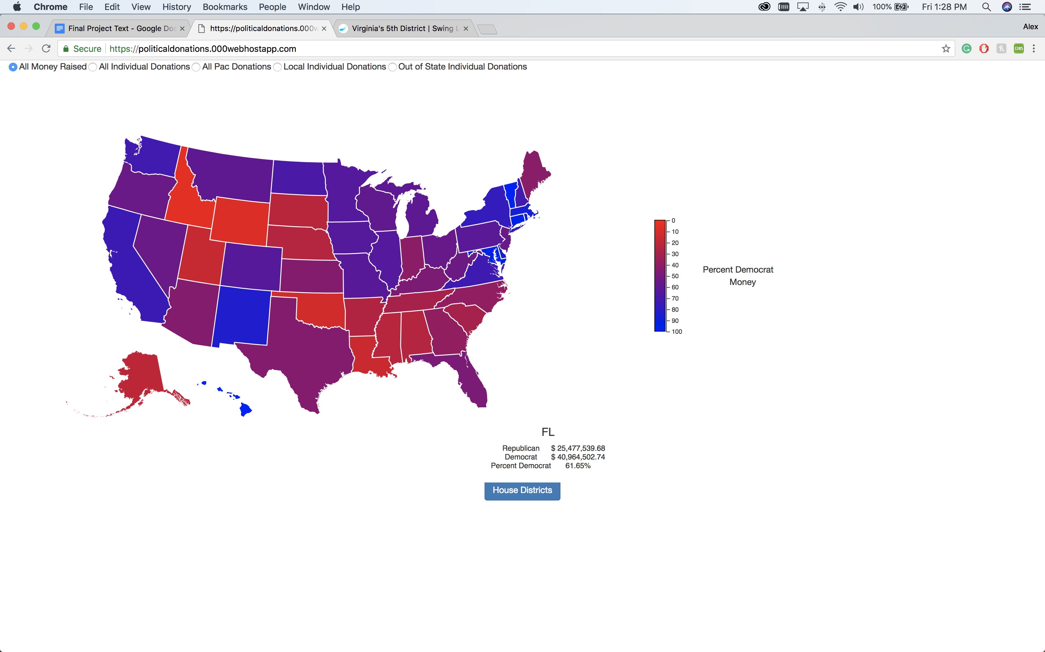

**Percent Money Donated By All Individuals to All Candidates - States**

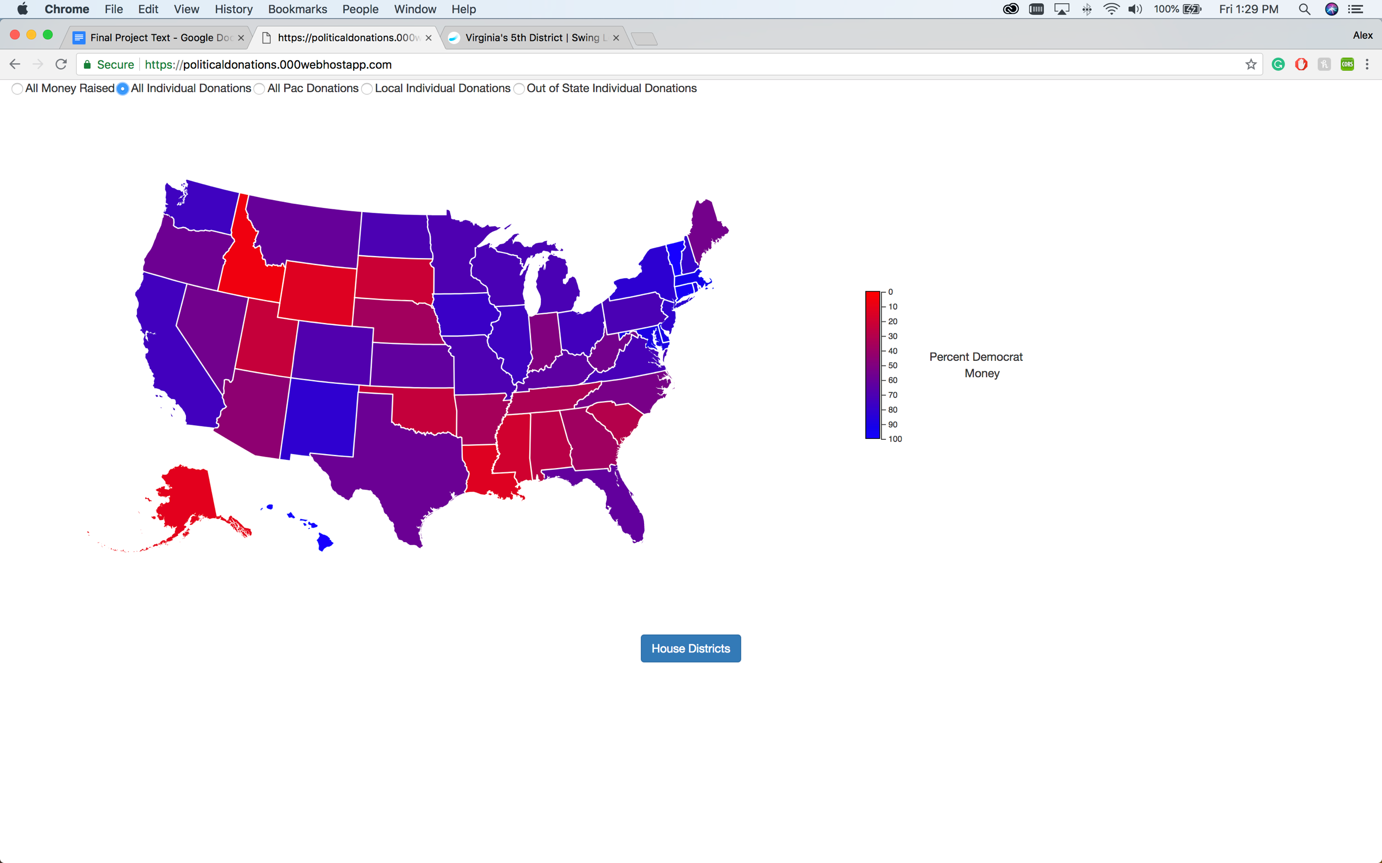

**Percent of Local Money Donated by Individuals to Candidates - States**

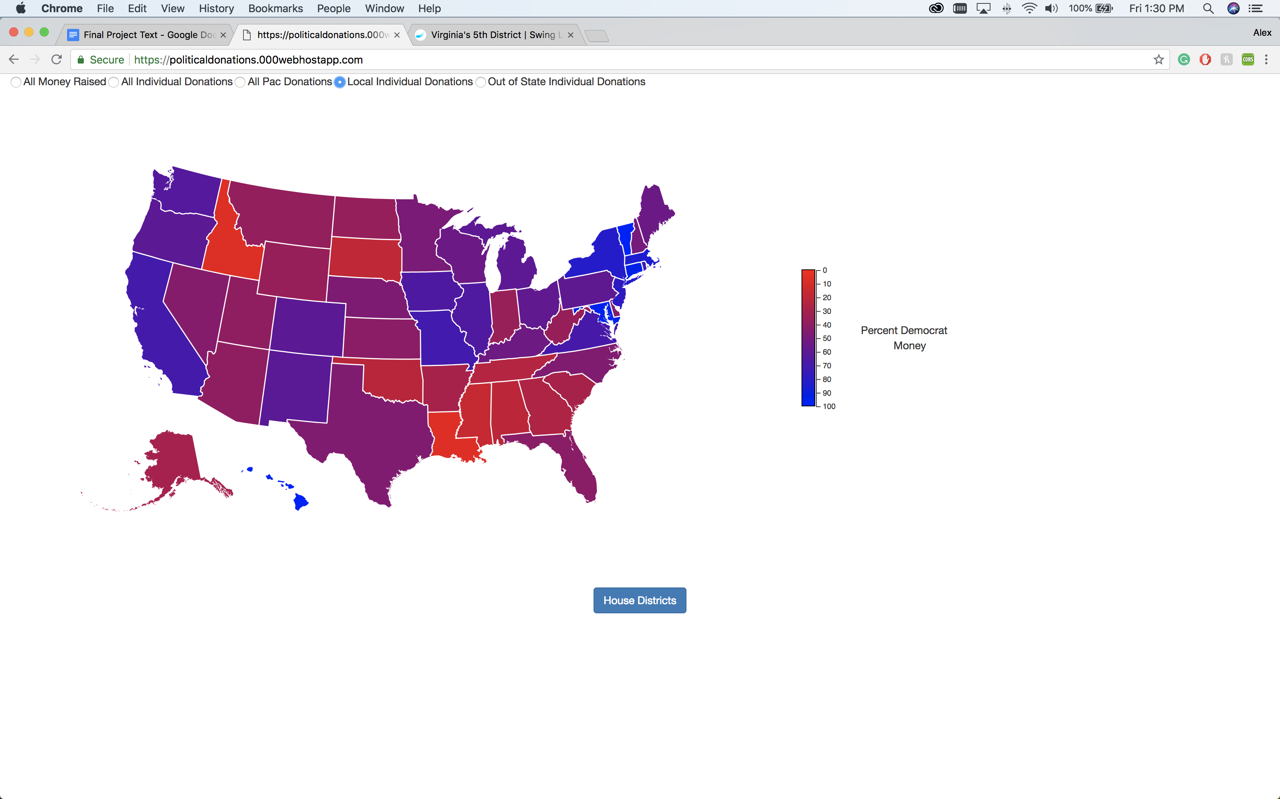

**Percent of Out-of-State Money Donated by Individuals to Candidates - States**

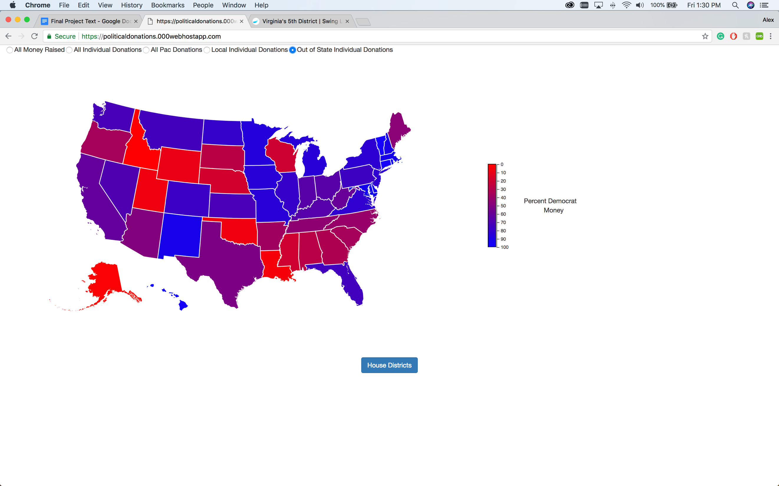

**Percent of PAC Money Donated to Candidates - States**

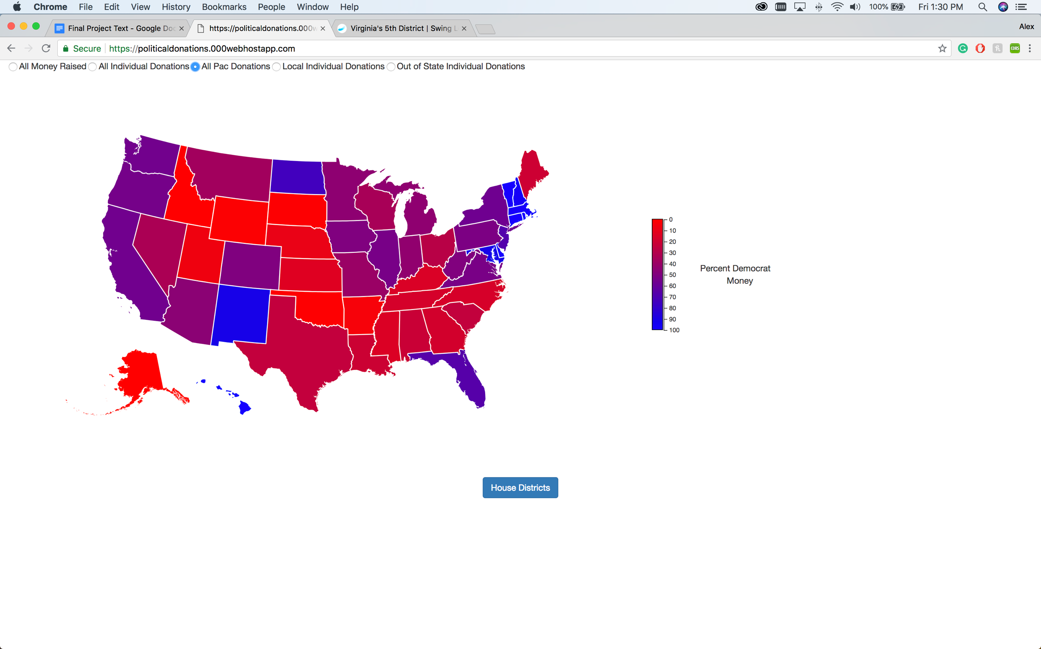

**Percent of All Money Raised By All Candidates – Districts**

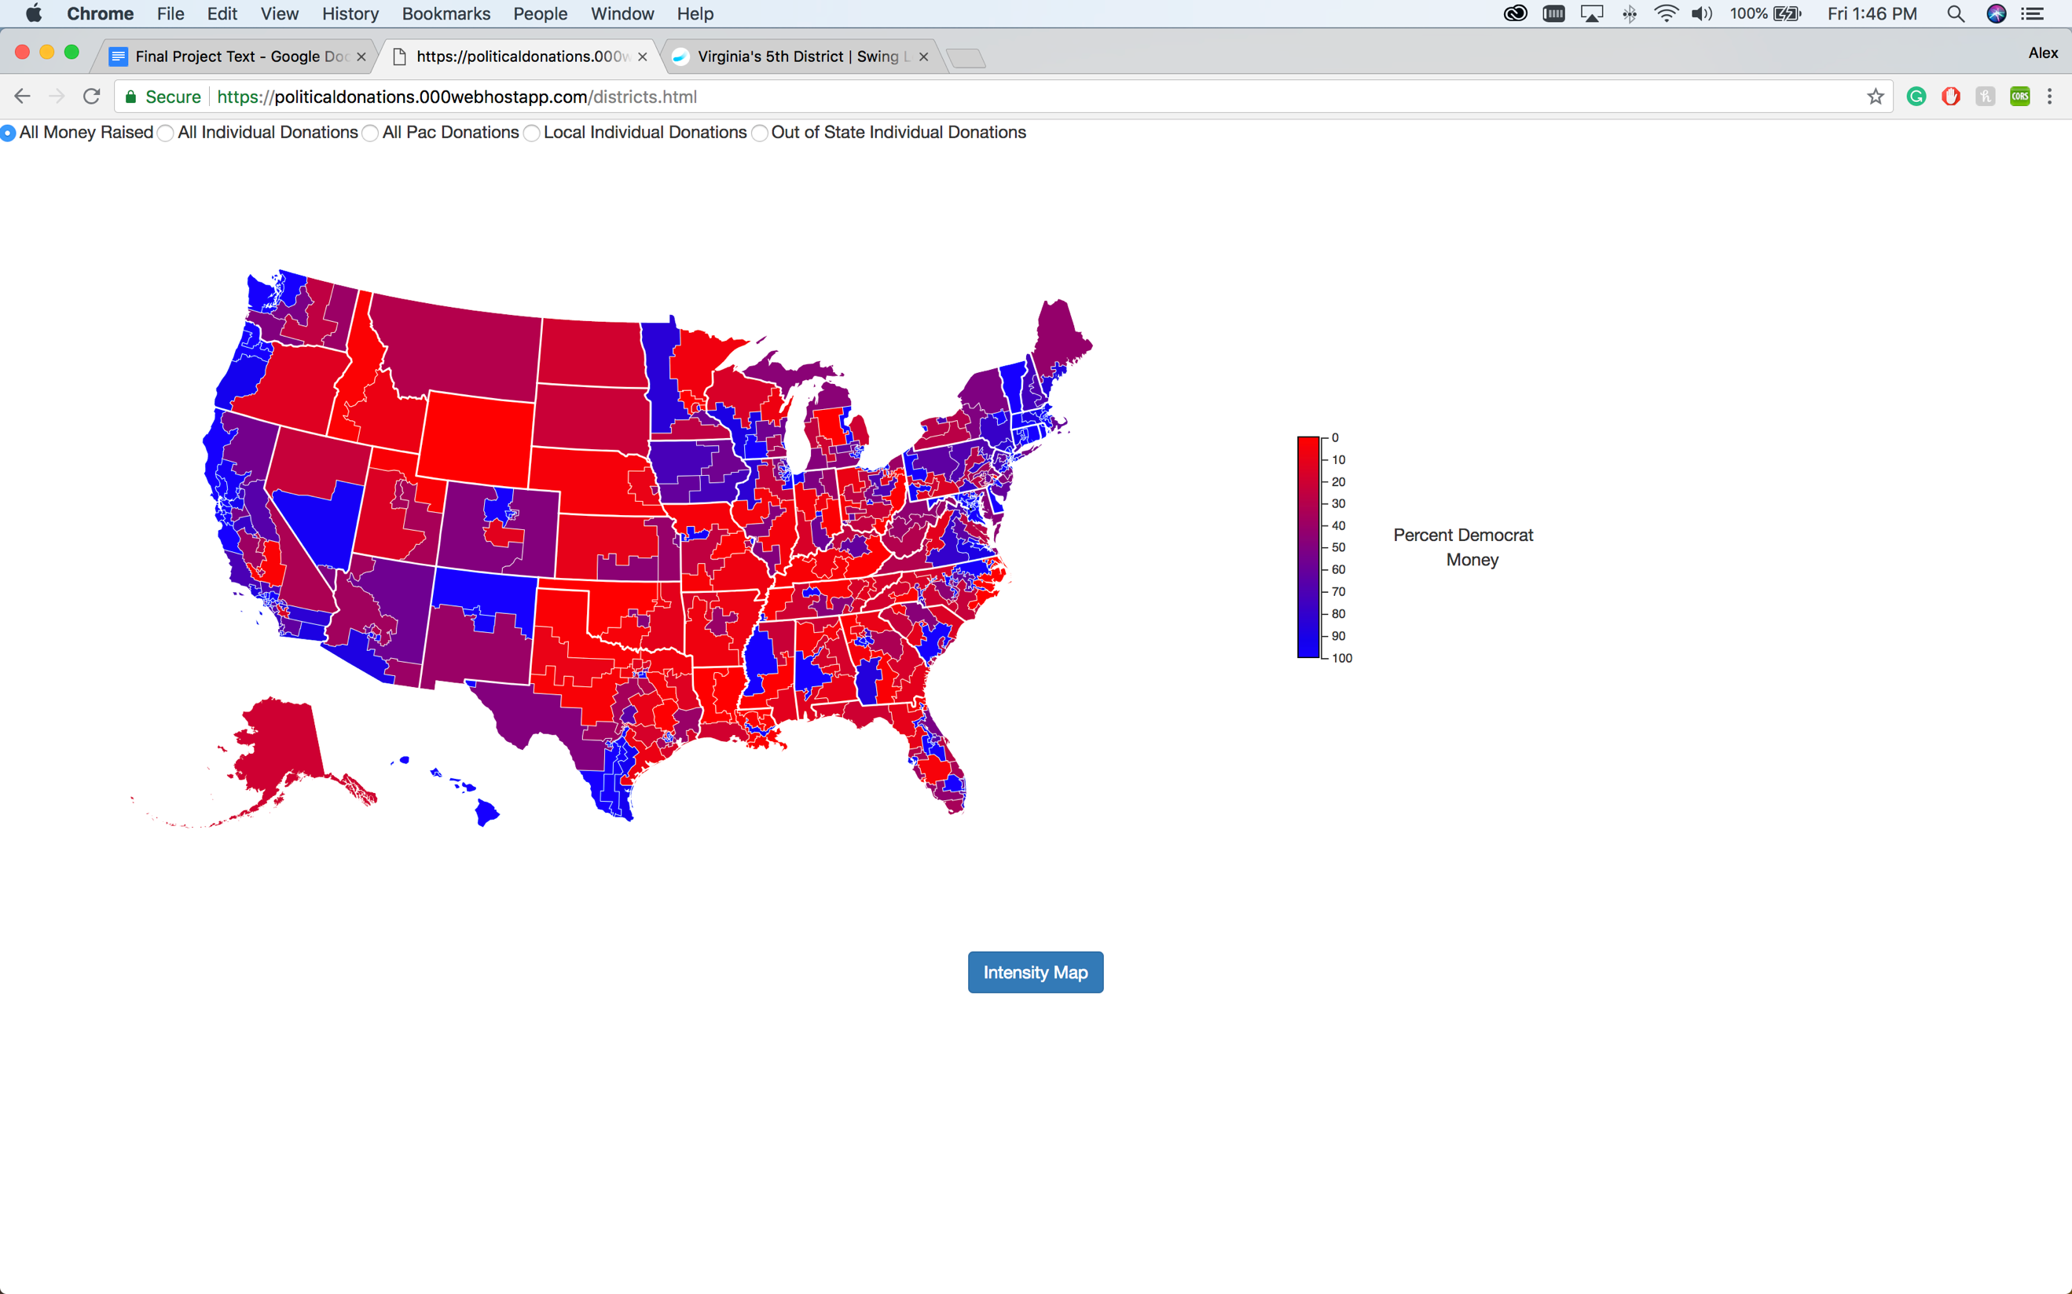

**Percent Money Donated By All Individuals to All Candidates – Districts**

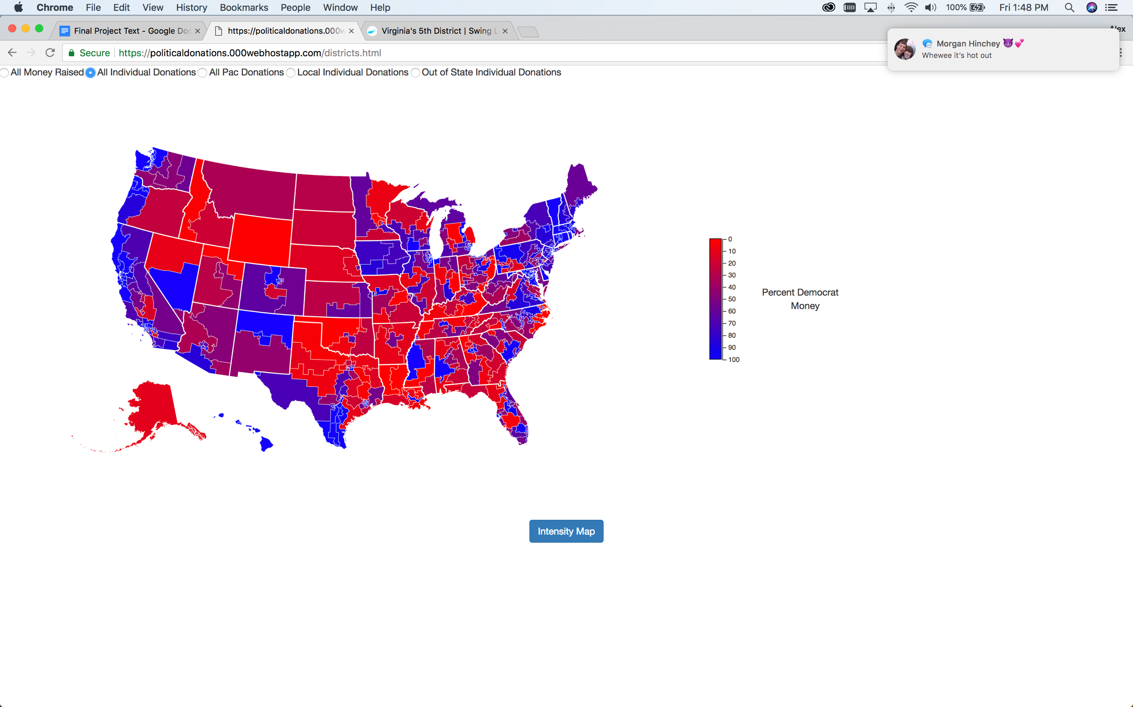

**Percent of Local Money Donated by Individuals to Candidates – Districts**

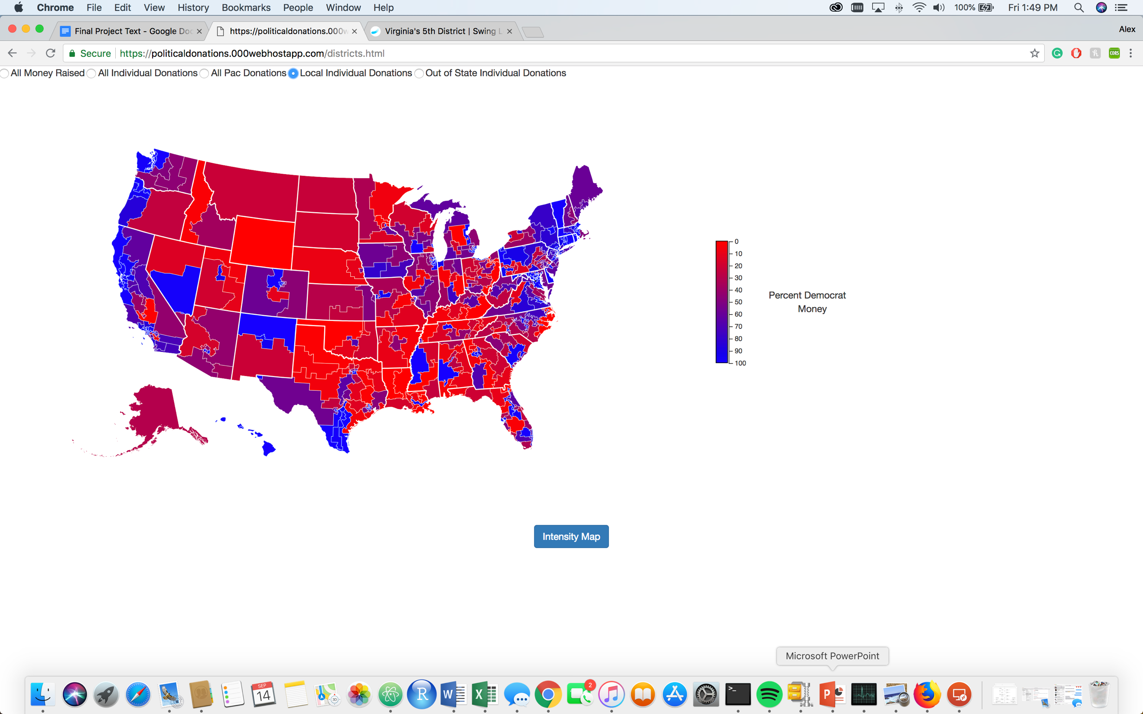

**Percent of Out-of-State Money Donated by Individuals to Candidates – Districts**

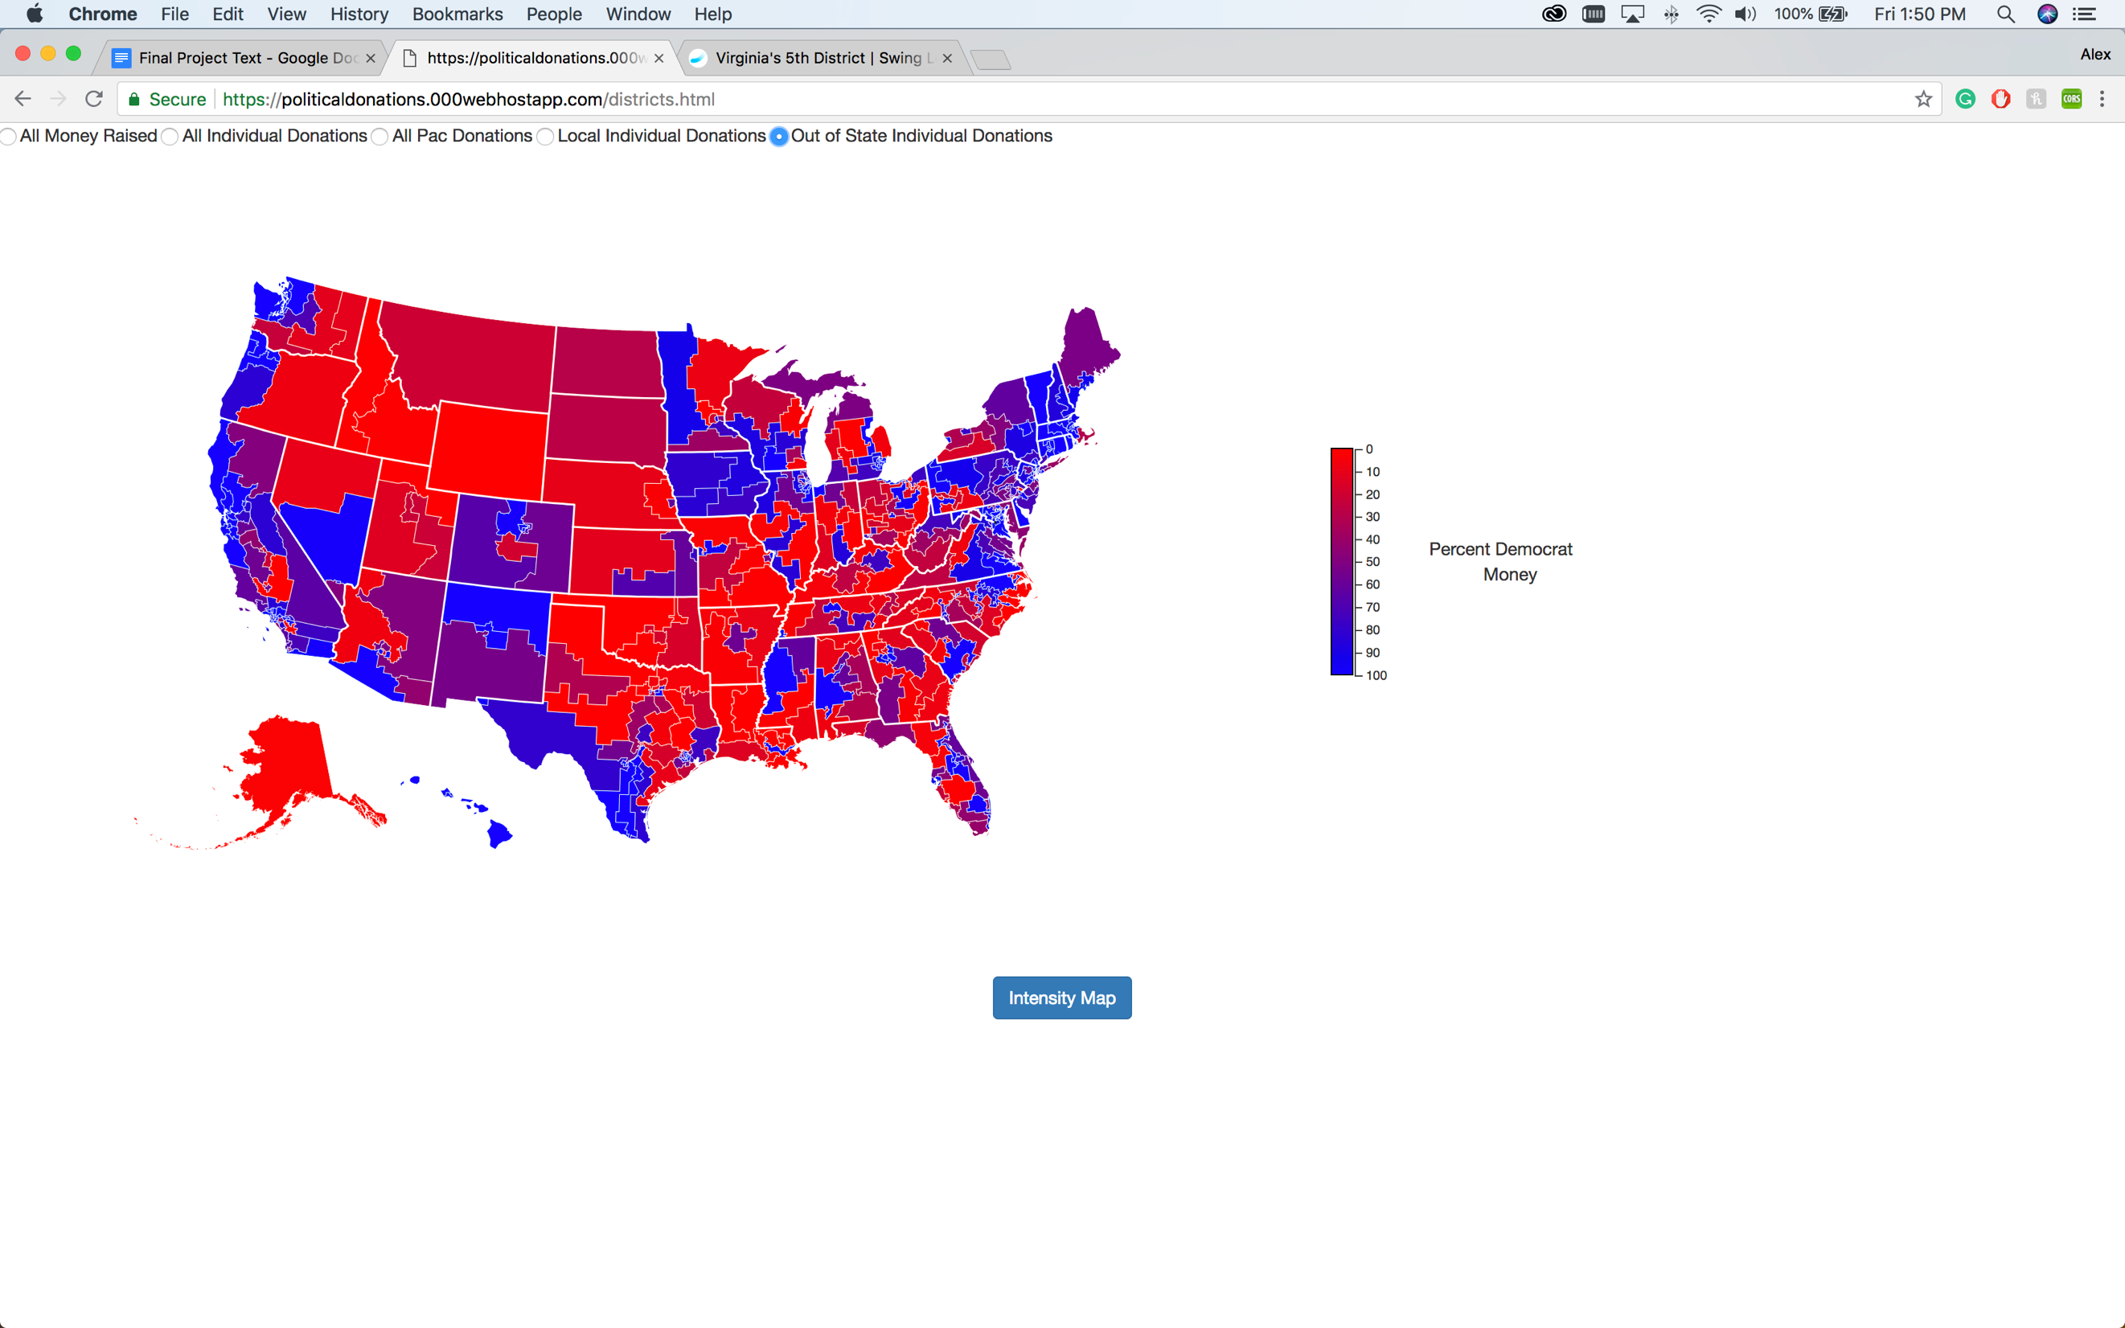

**Percent of PAC Money Donated to Candidates - Districts**

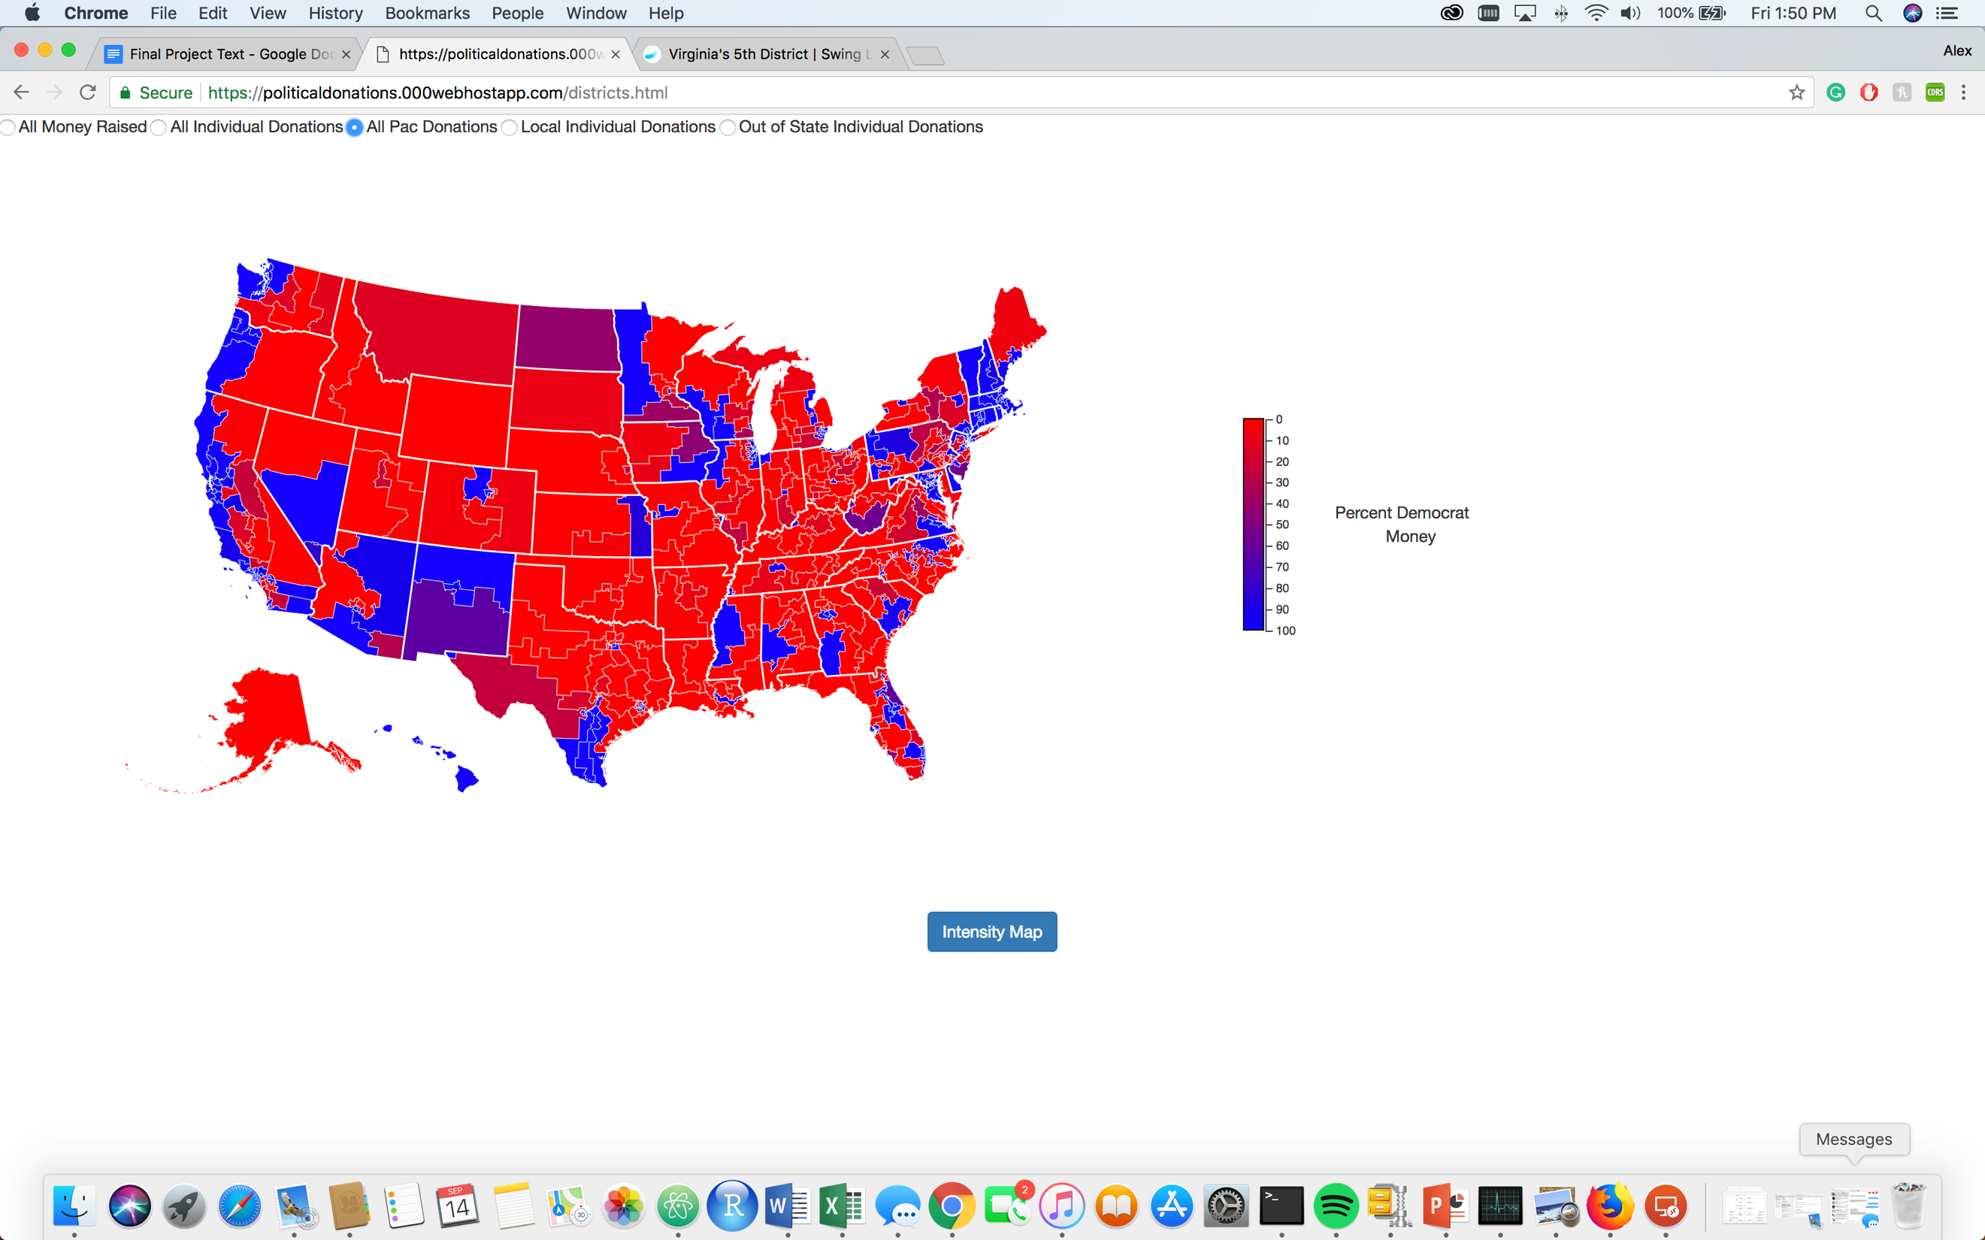

**Intensity Map – Districts**

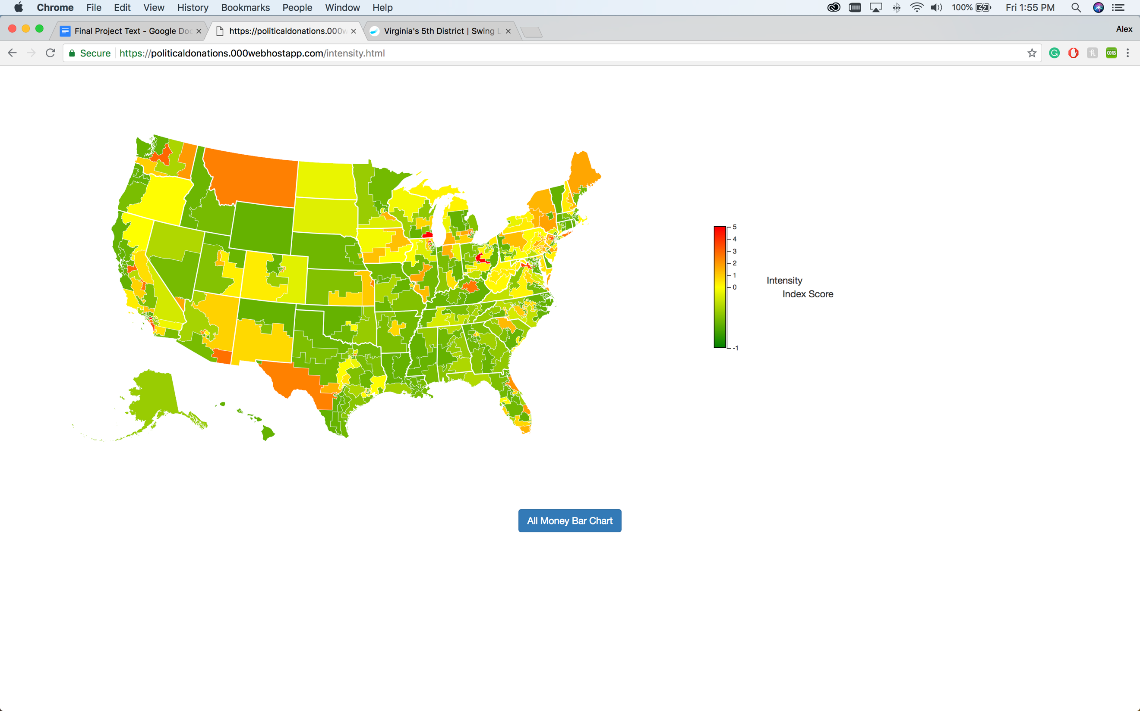

**All Elections Money**

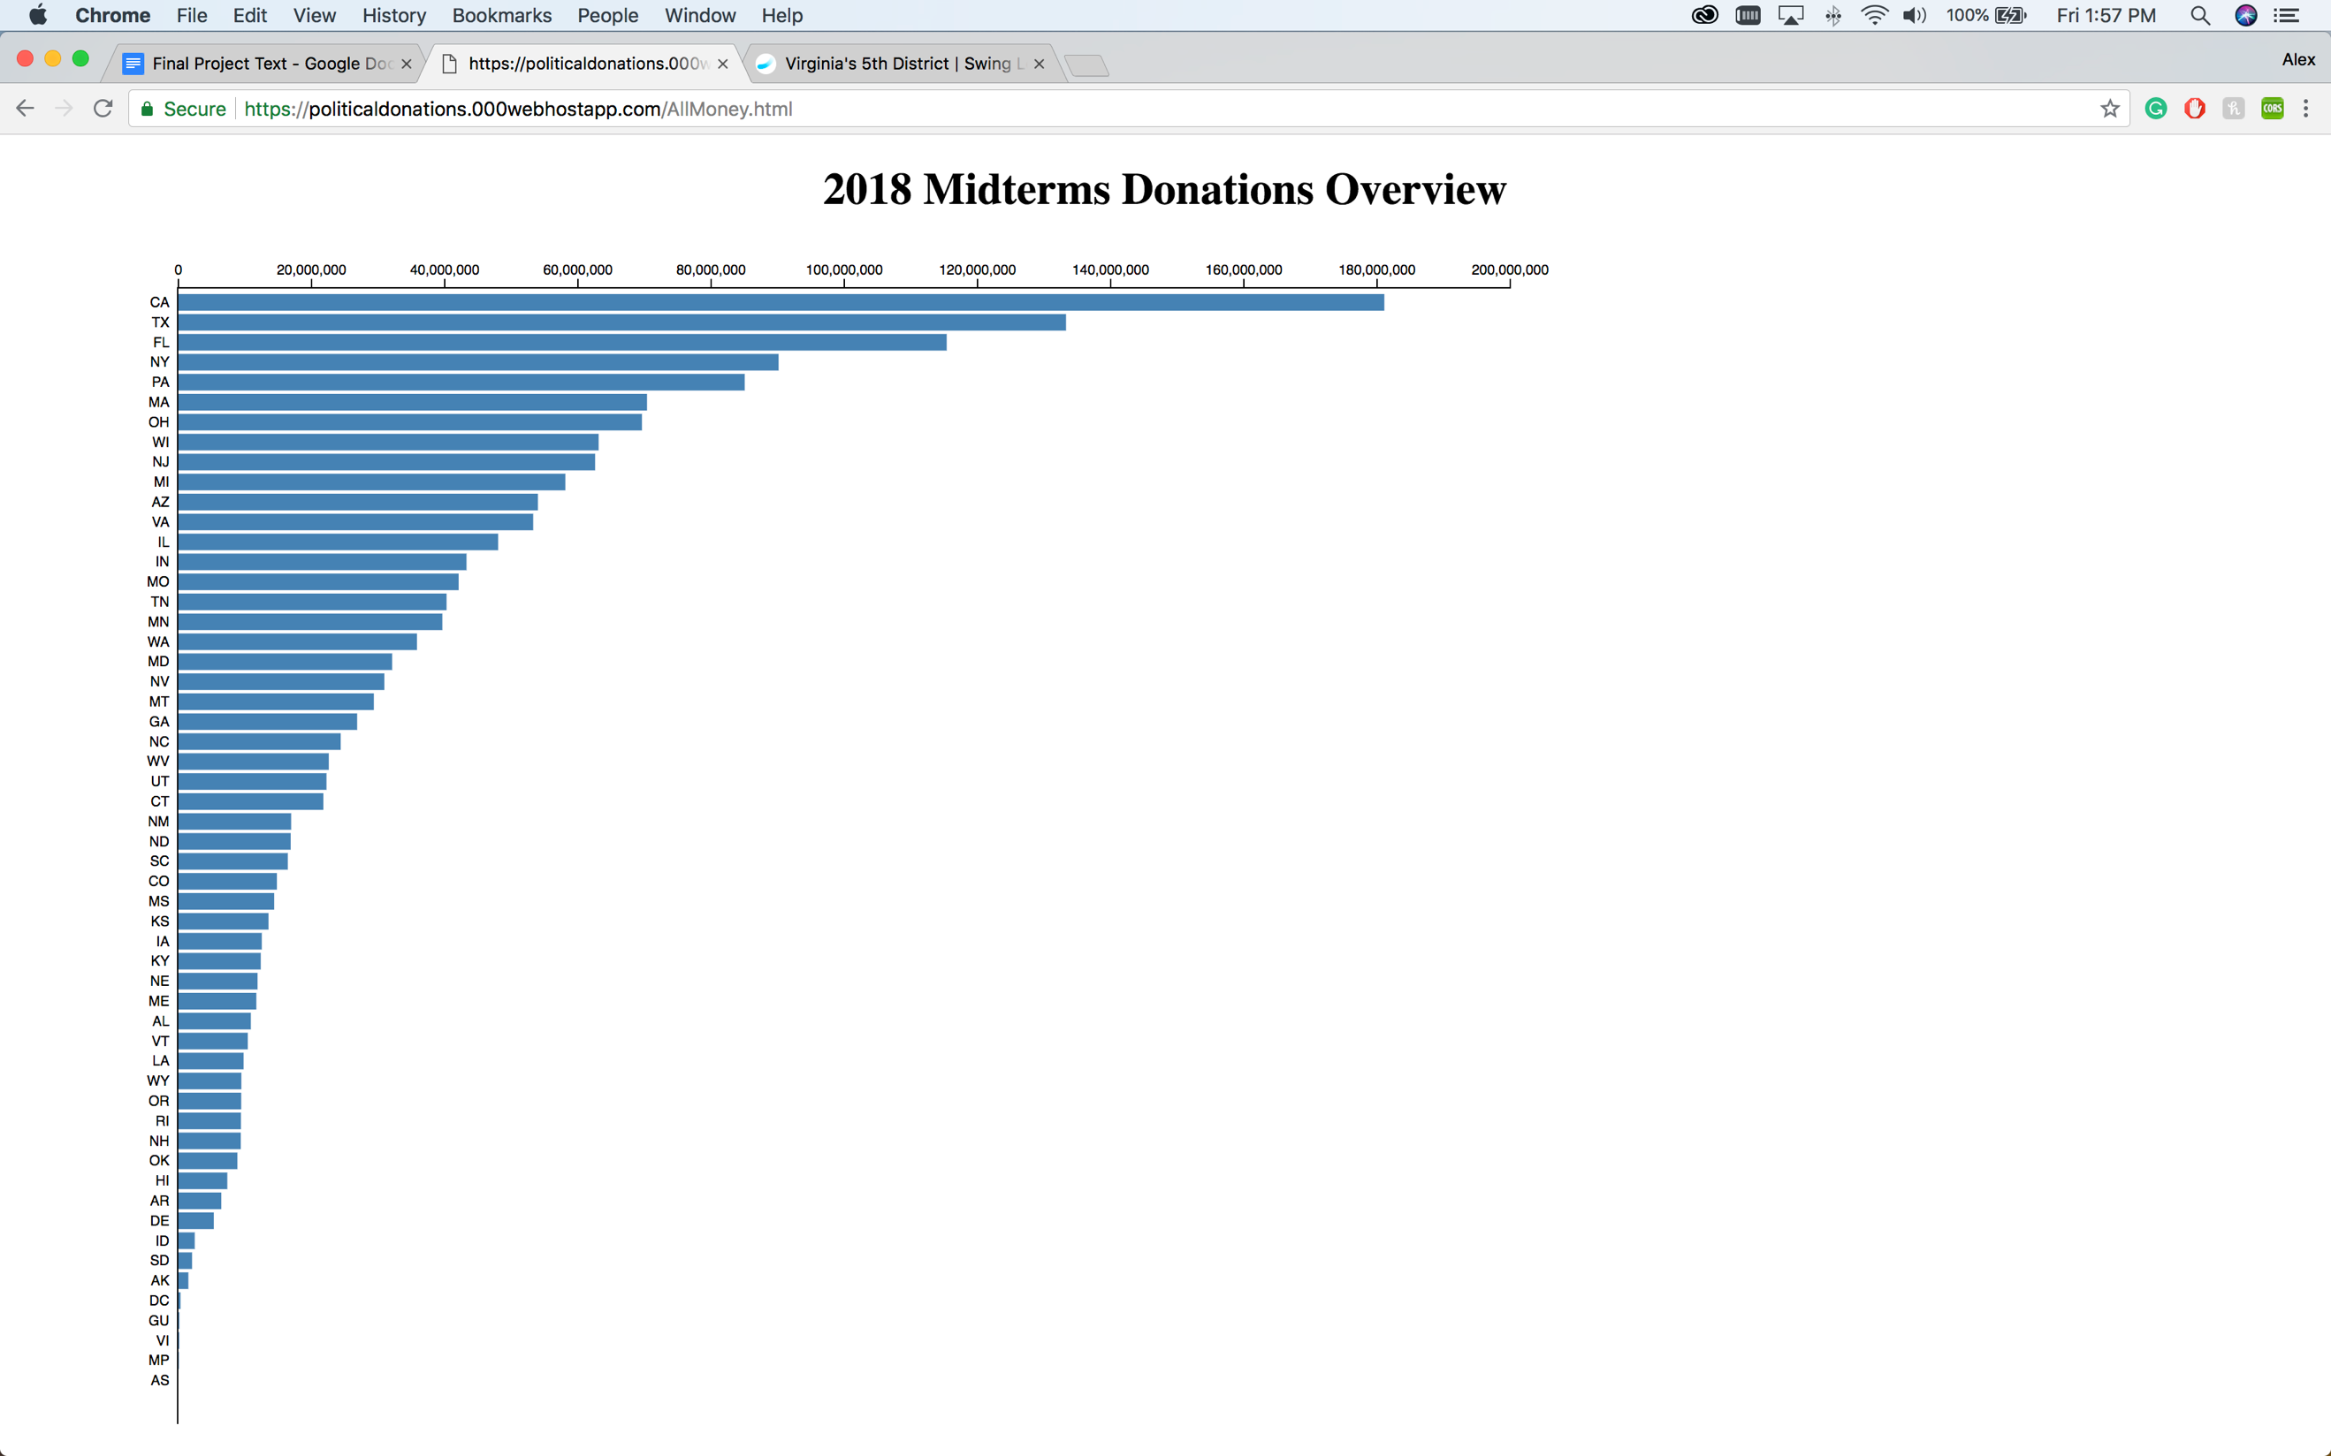

**All Elections – California**

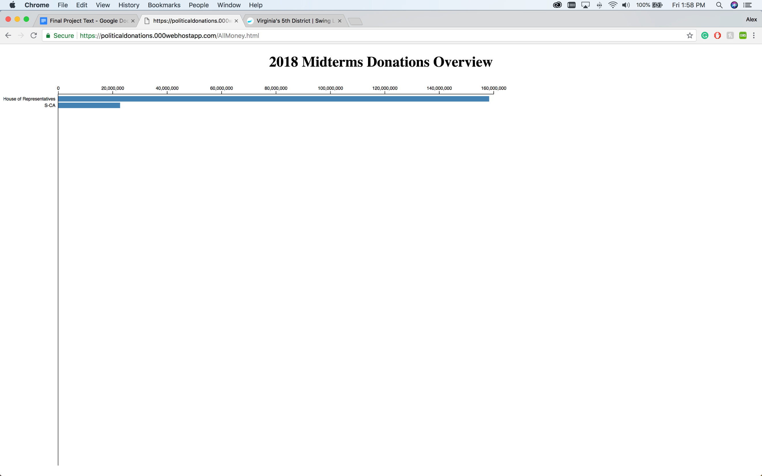

**All Elections – California House of Representatives**

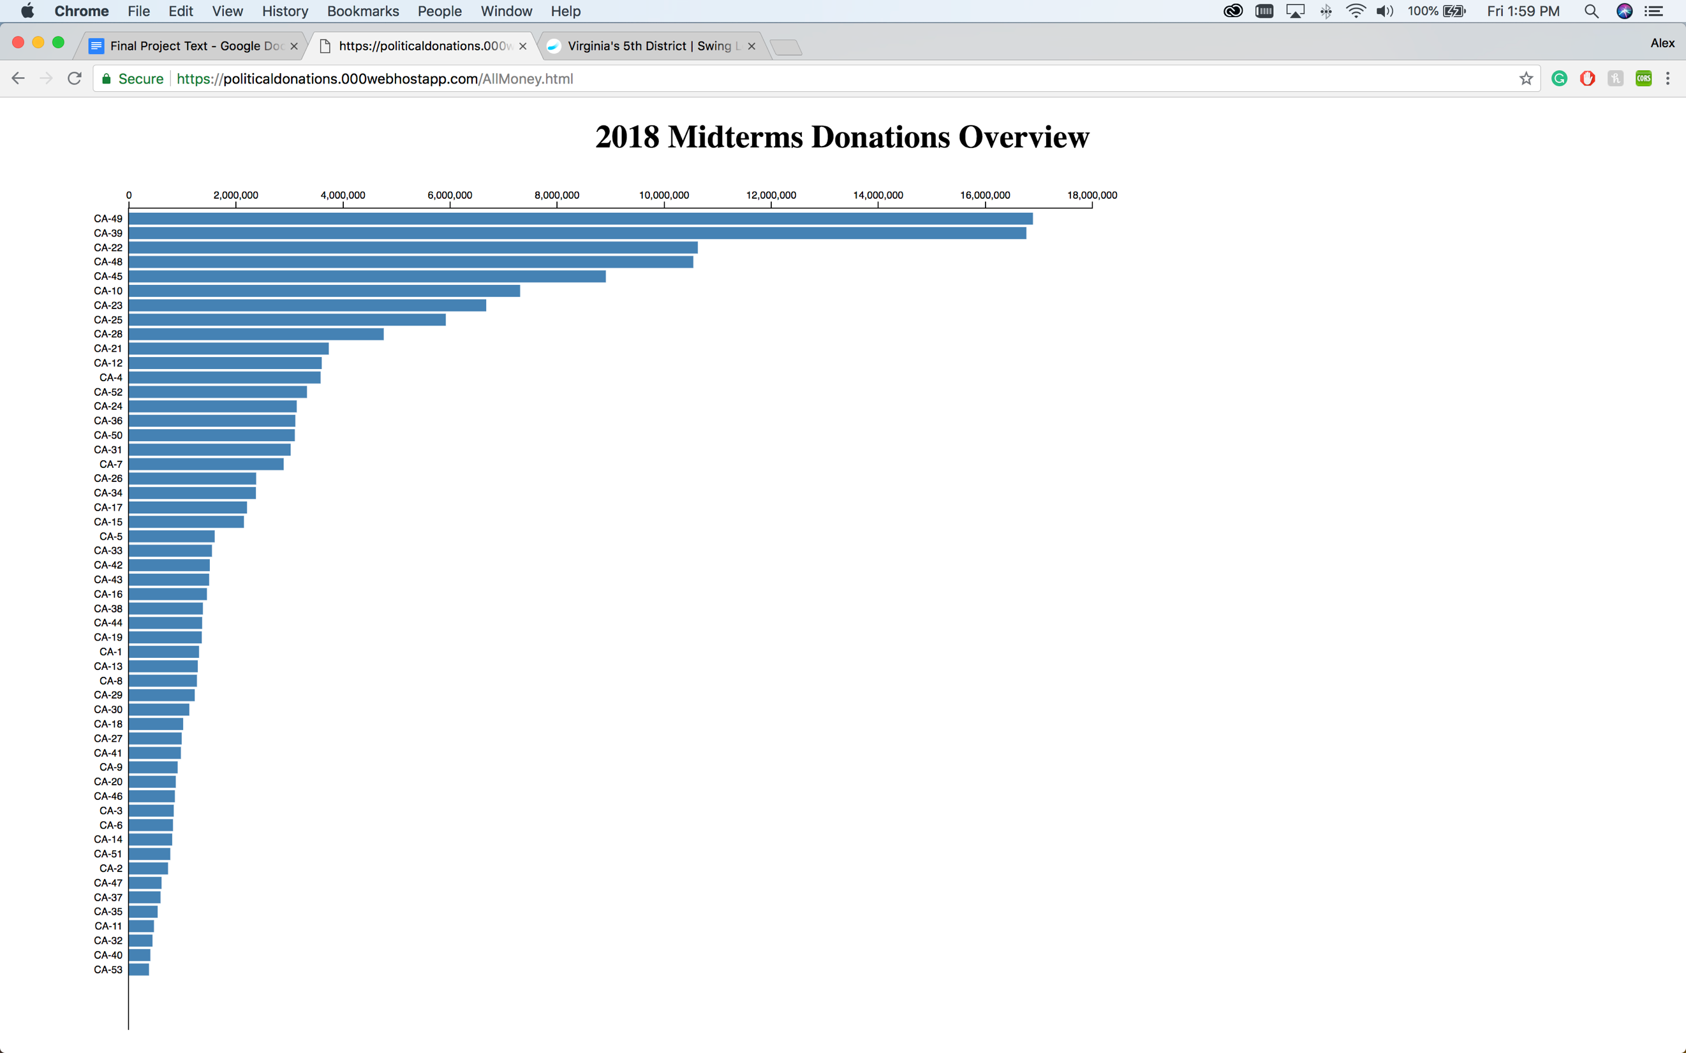

**All Candidates – CA–49**

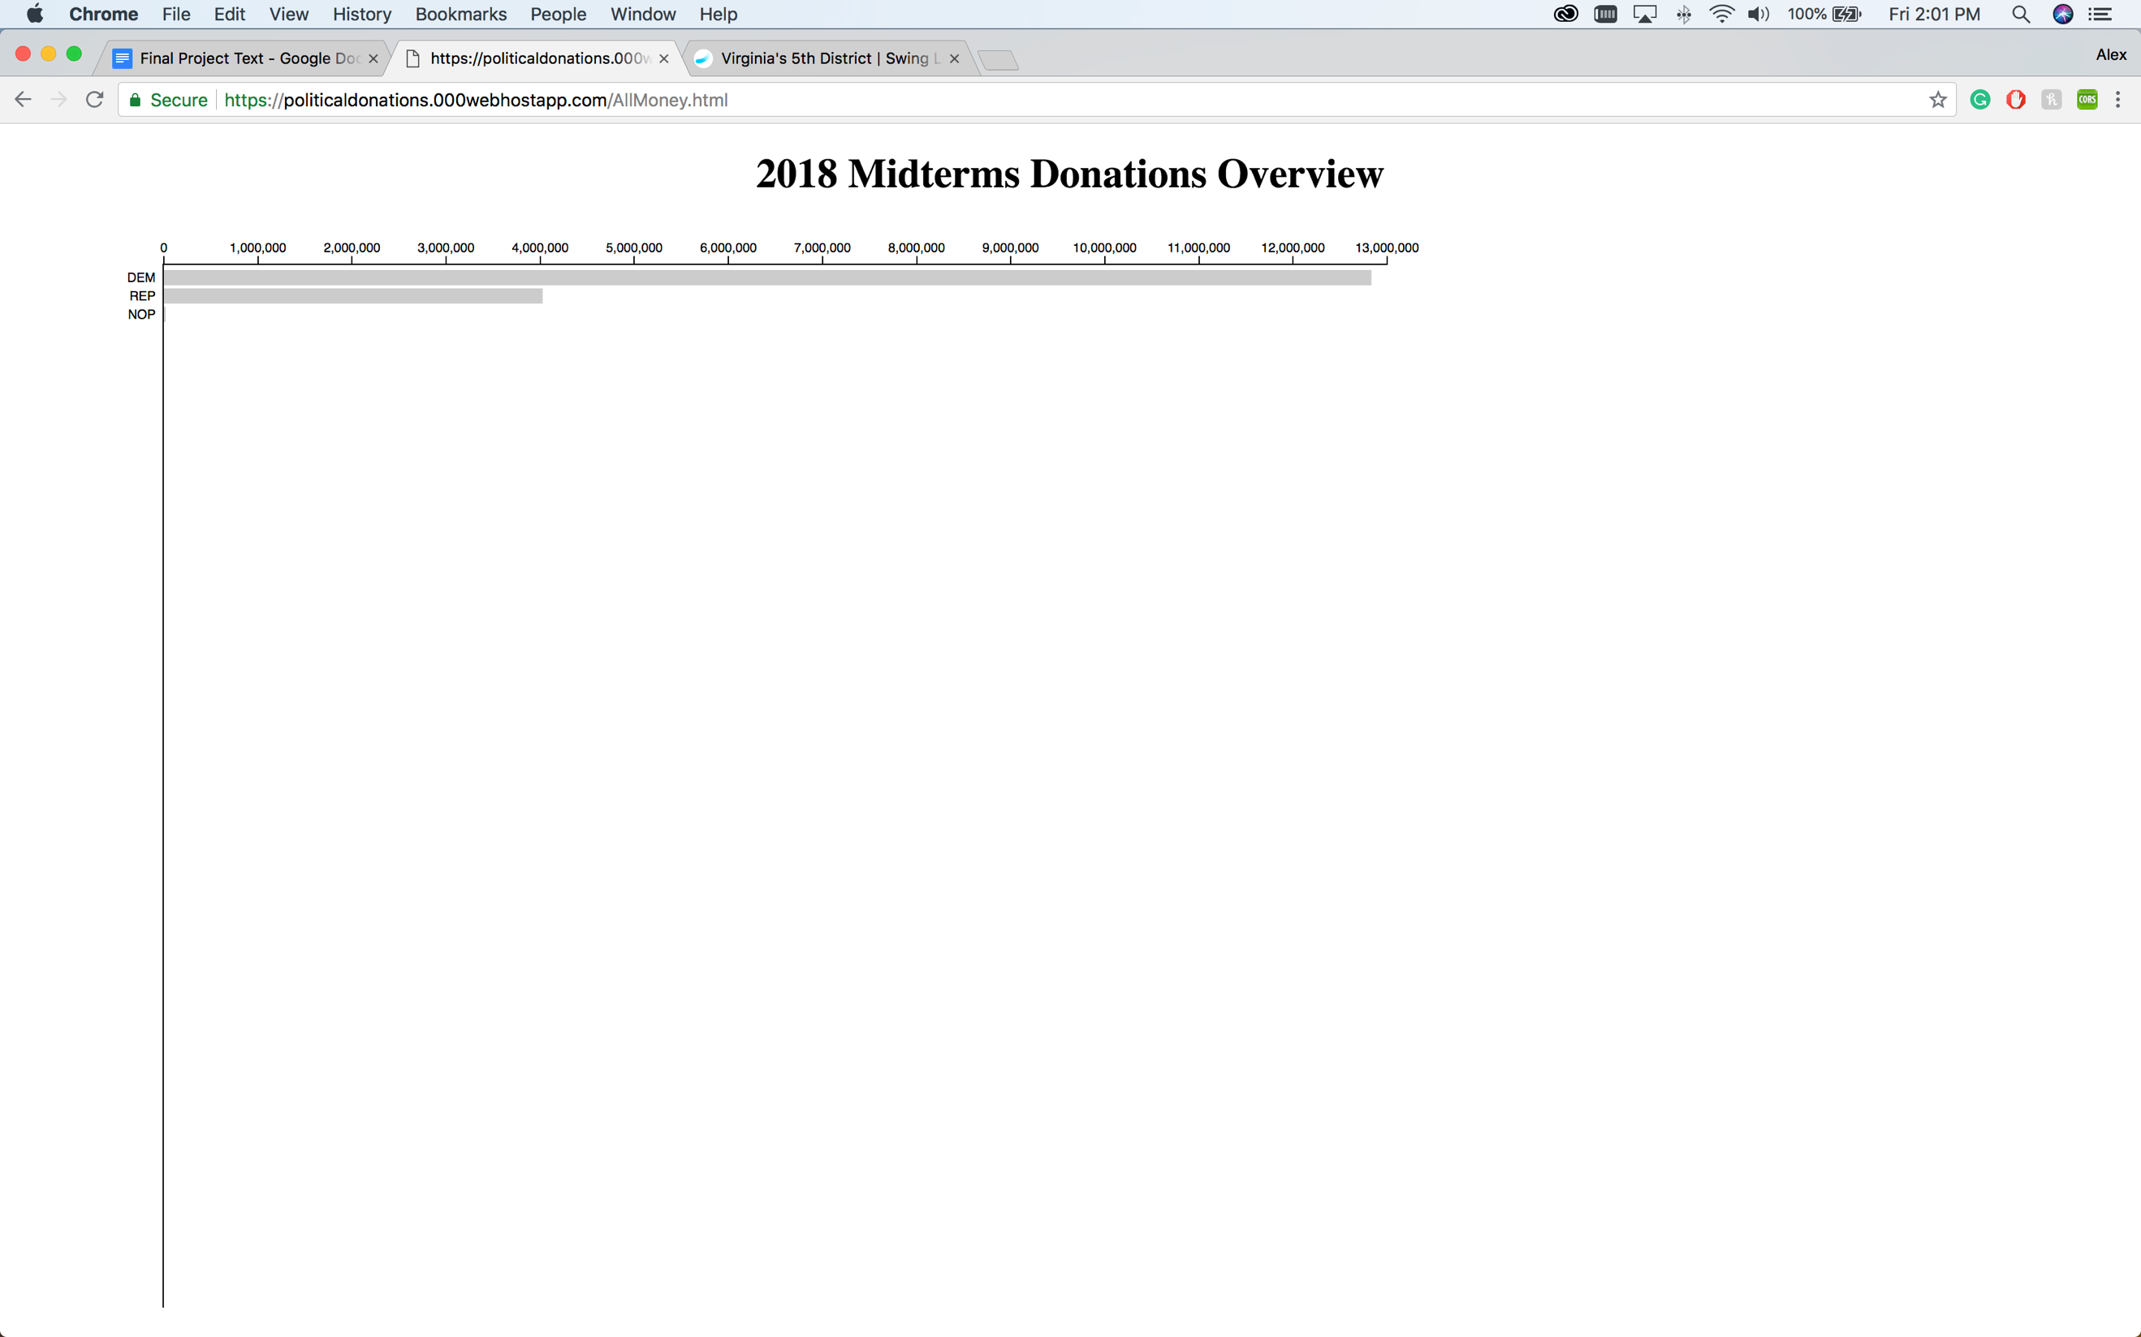

1. Note that this does not include “Super PACs”. Super PACs have no limit in raising or spending money, however money spent by Super PACs is not directly spent on candidate. Super PACs that spend money in support of a candidate are required to use the money independent from the actual candidate committee.
2. All descriptions of structured data files from the FEC website are provided at https://www.fec.gov/data/advanced/?tab=bulk-data
3. An example of the campaign committee website for Joe Donnelly, Incumbent senator of Indiana, for the 2018 Midterm election from 2017-2018 is provided here: https://www.fec.gov/data/candidate/S2IN00091/?cycle=2018&election_full=true
4. Congressional district and United States shapefile provided here: <https://www.census.gov/geo/maps-data/data/tiger-line.html>
5. The bureau of labor statistics web site with the FIPS codes is located here: https://www.bls.gov/cew/cewedr10.htm
6. Tutorials for the visualizations are located here: https://github.com/d3/d3/wiki/Tutorials
7. The visualizations are being hosted here: https://politicaldonations.000webhostapp.com/
8. Supplied by the FEC https://www.fec.gov/campaign-finance-data/candidate-master-file-description/
9. Supplied by the FEC https://www.fec.gov/campaign-finance-data/all-candidates-file-description/
10. Supplied by the FEC https://www.fec.gov/campaign-finance-data/committee-master-file-description/
11. Supplied by the FEC ttps://www.fec.gov/campaign-finance-data/candidate-committee-linkage-file-description/
12. Supplied by the FEC https://www.fec.gov/campaign-finance-data/contributions-individuals-file-description/